**Naïve Bayes Classifier: An Example**

P(Ci): P(buys_computer = “yes”) = 9/14 = 0.643 P(buys_computer = “no”) = 5/14= 0.357

Compute P(X|Ci) for each class

P(age = “<=30”|buys_computer = “yes”) = 2/9 = 0.222

P(age = “<= 30”|buys_computer = “no”) = 3/5 = 0.6

P(income = “medium” | buys_computer = “yes”) = 4/9 = 0.444

P(income = “medium” | buys_computer = “no”) = 2/5 = 0.4

P(student = “yes” | buys_computer = “yes) = 6/9 = 0.667

P(student = “yes” | buys_computer = “no”) = 1/5 = 0.2

P(credit_rating = “fair” | buys_computer = “yes”) =6/9 = 0.667

P(credit_rating = “fair” | buys_computer = “no”) = 2/5 = 0.4

X = (age <= 30 , income = medium, student = yes, credit_rating = fair)

P(X|Ci) : P(X|buys_computer = “yes”) = 0.222 x 0.444 x 0.667 x 0.667 = 0.044

P(X|buys_computer = “no”) = 0.6 x 0.4 x 0.2 x 0.4 = 0.019

P(X|Ci)*P(Ci) : P(X|buys_computer = “yes”) * P(buys_computer = “yes”) = 0.028 P(X|buys_computer = “no”) * P(buys_computer = “no”) = 0.007

Therefore, X belongs to class (“buys_computer = yes”)

**Avoiding the Zero-Probability Problem**

- Naïve Bayesian prediction requires each conditional prob. be non-zero. Otherwise, the predicted prob. will be zero

- Ex. Suppose a dataset with 1000 tuples, income=low (0), income= medium (990), and income = high (10)

- Use Laplacian correction (or Laplacian estimator) --- Adding 1 to each case ----- Prob(income = low) = 1/1003 ----- Prob(income = medium) = 991/1003 ----- Prob(income = high) = 11/1003 --- The “corrected” prob. estimates are close to their “uncorrected” counterparts

**Naïve Bayes Classifier: Comments**

- Advantages --- Easy to implement --- Good results obtained in most of the cases

- Disadvantages --- Assumption: class conditional independence, therefore loss of accuracy ---Practically, dependencies exist among variables ----- E.g., hospitals: patients: Profile: age, family history, etc.

Symptoms: fever, cough etc., Disease: lung cancer, diabetes, etc. ----- Dependencies among these cannot be modeled by Naïve Bayes Classifier

- How to deal with these dependencies? Bayesian Belief Networks (Chapter 9)

**Model Evaluation and Selection**

- Evaluation metrics: How can we measure accuracy? Other metrics to consider? - Use **validation test set** of class-labeled tuples instead of training set when assessing accuracy - Methods for estimating a classifier’s accuracy: --- Holdout method, random subsampling --- Cross-validation --- Bootstrap - Comparing classifiers:--- Confidence intervals--- Cost-benefit analysis and ROC Curves

**Classifier Evaluation Metrics: Confusion Matrix**

**Confusion Matrix:**

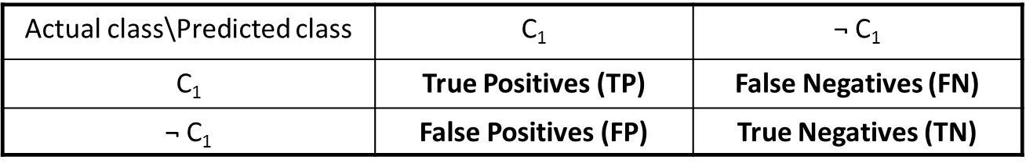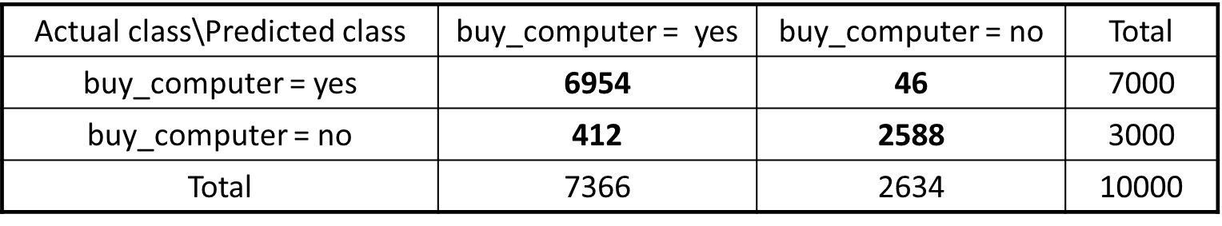

- Given m classes, an entry, CMi,j in a confusion matrix indicates # of tuples in class i that were labeled by the classifier as class j

--- May have extra rows/columns to provide totals

**Classifier Evaluation Metrics: Accuracy, Error Rate, Sensitivity and Specificity**

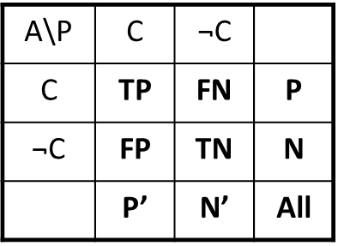- Classifier Accuracy, or recognition rate: percentage of test set tuples that are correctly classified

Accuracy = (TP + TN)/All

- Error rate: 1 – accuracy, or

Error rate = (FP + FN)/All

**Class Imbalance Problem**:

One class may be *rare*, e.g. fraud, or HIV-positive

Significant *majority of the negative class* and minority of the positive class

**Sensitivity**: True Positive recognition rate Sensitivity = TP/P

**Specificity**: True Negative recognition rate Specificity = TN/N

**Classifier Evaluation Metrics: Precision and Recall, and F-measures**

**Precision:** exactness: what % of tuples that the classifier labeled as positive are actually positive $precision= \frac{TP}{TP+FP}$

**Recall:** completeness – what % of positive tuples did the classifier label as positive $recall= \frac{TP}{TP+FN}$

Comment: --- Perfect score is 1.0 --- Inverse relationship between precision & recall

**F measure (or F-score):** harmonic mean of precision and recall ---In general, it is the weighted measure of precision & recall $F= \frac{1}{\frac{α}{P}+(1-α)/R}= \frac{\left(β^{2}+1\right)PR}{β^{2}P+R}$ Assigning β times as much weight to recall as to precision; F1-measure (balanced F-measure) That is, when β = 1, $F_{1}= \frac{2pR}{P+R}$

**Evaluating Classifier Accuracy: Holdout & Cross-Validation Methods & Bootstrap**

**Holdout method** - Given data is randomly partitioned into two independent sets --- Training set (e.g., 2/3) for model construction --- Test set (e.g., 1/3) for accuracy estimation

- Random sampling: a variation of holdout --- Repeat holdout k times, accuracy = avg. of the accuracies obtained

**Cross-validation (k-fold, where k = 10 is most popular)**

- Randomly partition the data into k mutually exclusive subsets, each approximately equal size - At i-th iteration, use Di as test set and others as training set - Leave-one-out: k folds where k = # of tuples, for small sized data - *Stratified cross-validation*: folds are stratified so that class dist. in each fold is approx. the same as that in the initial data

**Bootstrap**

--- Works well with small data sets --- Samples the given training tuples uniformly with replacement ----- Each time a tuple is selected, it is equally likely to be selected again and re-added to the training set - Several bootstrap methods, and a common one is .632 boostrap --- A data set with d tuples is sampled d times, with replacement, resulting in a training set of d samples. The data tuples that did not make it into the training set end up forming the test set. About 63.2% of the original data end up in the bootstrap, and the remaining 36.8% form the test set (since (1 – 1/d)d ≈ e-1 = 0.368)

--- Repeat the sampling procedure k times, overall accuracy of the model: $Acc\left(M\right)=\frac{1}{k}\sum_{i=1}^{k}{(0.632*{Acc\left(M_{i}\right)}_{test_Set}+0.368*{Acc\left(M_{i}\right)}_{train_set}}$

**EstimatingConfidenceIntervals:ClassifierModelsM1 vs. M2**

- Suppose we have 2 classifiers, M1 and M2, which one is better? - Use 10-fold cross-validation to obtain $\overline{err}(M_{1})$ and $\overline{err}(M_{2})$- These mean error rates are just estimates of error on the true population of future data cases - What if the difference between the 2 error rates is just attributed to chance?--- Use a test of statistical significance --- Obtain confidence limits for our error estimates

**Estimating Confidence Intervals: Null Hypothesis**

- Perform 10-fold cross-validation - Assume samples follow **a t distribution** with k–1 **degrees of freedom** (here, k=10)

- Use t-test (or Student’s t-test) **- Null Hypothesis**: M1 & M2 are the same - If we can **reject** null hypothesis, then --- we conclude that the difference between M1 & M2 is **statistically significant** --- Chose model with lower error rate

**Estimating Confidence Intervals: t-test**

- If only 1 test set available: **pairwise comparison**

--- For ith round of 10-fold cross-validation, the same cross partitioning is used to obtain err(M1)i and err(M2)i

--- Average over 10 rounds to get $\overline{err}(M_{1})$ and $\overline{err}(M_{2})$

--- **t-tes**t computes **t-statistic** with k-1 **degrees of freedom**:

$$t= \frac{\overline{err}\left(M_{1}\right)- \overline{err}(M_{2})}{\sqrt{var(M_{1}-M_{2})/k}}$$

Where $var\left(M_{1}-M_{2}\right)= \sqrt{\frac{var(M_{1})}{k_{1}}+\frac{var(M_{2})}{k_{2}}}$

If two test sets available: use **non-paired t-test**

$$var\left(M_{1}-M_{2}\right)= \frac{1}{k}\sum_{i=1}^{k}{[err{\left(M_{1}\right)}_{i}-}err{\left(M_{2}\right)}_{i}-(\overline{err}\left(M_{1}\right)- \overline{err}\left(M_{2}\right))]^2$$

where *k1* & *k2* are # of cross-validation samples used for *M1* & *M2*, resp

**Estimating Confidence Intervals: Table for t-distribution**

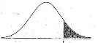- Symmetric

- Significance level, e.g., sig = 0.05 or 5% means M1 & M2 are significantly different for 95% of population

- Confidence limit, z = sig/2

Estimating Confidence Intervals: Statistical Significance

- Are M1 & M2 significantly different? --- Compute t. Select significance level (e.g. sig = 5%) --- Consult table for t-distribution: Find t value corresponding to k-1 degrees of freedom (here, 9) --- t-distribution is symmetric: typically upper % points of distribution shown → look up value for confidence limit z=sig/2 (here, 0.025) --- If t > z or t < -z, then t value lies in rejection region: -----Reject null hypothesis that mean error rates of M1 & M2 are same ----- Conclude: statistically significant difference between M1 & M2 --- Otherwise, conclude that any difference is chance

Model Selection: ROC Curves

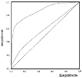- ROC (Receiver Operating Characteristics) curves: for visual comparison of classification models - Originated from signal detection theory - Shows the trade-off between the true positive rate and the false positive rate - The area under the ROC curve is a measure of the accuracy of the model - Rank the test tuples in decreasing order: the one that is most likely to belong to the positive class appears at the top of the list - The closer to the diagonal line (i.e., the closer the area is to 0.5), the less accurate is the model

- Vertical axis represents the true positive rate

- Horizontal axis rep. the false positive rate

- The plot also shows a diagonal line

- A model with perfect accuracy will have an area of 1.0

Issues Affecting Model Selection

- Accuracy --- classifier accuracy: predicting class label

- Speed --- time to construct the model (training time) --- time to use the model (classification/prediction time)

- Robustness: handling noise and missing values

- Scalability: efficiency in disk-resident databases

- Interpretability ---understanding and insight provided by the model

- Other measures, e.g., goodness of rules, such as decision tree size or compactness of classification rules

Ensemble Methods: Increasing the Accuracy

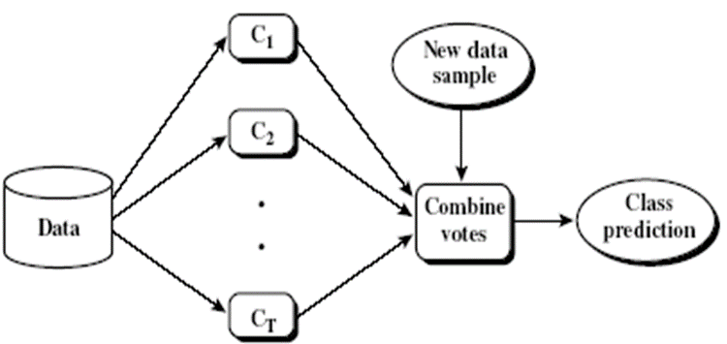- Ensemble methods --- Use a combination of models to increase accuracy --- Combine a series of k learned models, M1, M2, …, Mk, with the aim of creating an improved model M*

- Popular ensemble methods --- Bagging: averaging the prediction over a collection of classifiers --- Boosting: weighted vote with a collection of classifiers --- Ensemble: combining a set of heterogeneous classifiers

Bagging: Boostrap Aggregation

- Analogy: Diagnosis based on multiple doctors’ majority vote

- Training --- Given a set D of d tuples, at each iteration i, a training set Di of d tuples is sampled with replacement from D (i.e., bootstrap) --- A classifier model Mi is learned for each training set Di

- Classification: classify an unknown sample X --- Each classifier Mi returns its class prediction --- The bagged classifier M* counts the votes and assigns the class with the most votes to X

- Prediction: can be applied to the prediction of continuous values by taking the average value of each prediction for a given test tuple

- Accuracy: Proved improved accuracy in prediction --- Often significantly better than a single classifier derived from D --- For noise data: not considerably worse, more robust

Boosting

- Analogy: Consult several doctors, based on a combination of weighted diagnoses—weight assigned based on the previous diagnosis accuracy

- How boosting works? --- Weights are assigned to each training tuple --- A series of k classifiers is iteratively learned --- After a classifier Mi is learned, the weights are updated to allow the subsequent classifier, Mi+1, to pay more attention to the training tuples that were misclassified by Mi --- The final M* combines the votes of each individual classifier, where the weight of each classifier's vote is a function of its accuracy

- Boosting algorithm can be extended for numeric prediction

- Comparing with bagging: Boosting tends to have greater accuracy, but it also risks overfitting the model to misclassified data

Adaboost (Freund and Schapire, 1997)

- Given a set of d class-labeled tuples, (X1, y1), …, (Xd, yd)

- Initially, all the weights of tuples are set the same (1/d)

- Generate k classifiers in k rounds. At round i,

--- Tuples from D are sampled (with replacement) to form a training set Di of the same size

--- Each tuple’s chance of being selected is based on its weight

--- A classification model Mi is derived from Di

--- Its error rate is calculated using Di as a test set

--- If a tuple is misclassified, its weight is increased, o.w. it is decreased

- Error rate: err(Xj) is the misclassification error of tuple Xj. Classifier Mi error rate is the sum of the weights of the misclassified tuples:

- The weight of classifier Mi’s vote is $log\frac{⁡1-error\left(M_{i}\right)}{error\left(M_{i}\right)}$

Random Forest (Breiman 2001)

- Random Forest: --- Each classifier in the ensemble is a decision tree classifier and is generated using a random selection of attributes at each node to determine the split --- During classification, each tree votes and the most popular class is returned

- Two Methods to construct Random Forest: --- Forest-RI (random input selection): Randomly select, at each node, F attributes as candidates for the split at the node. The CART methodology is used to grow the trees to maximum size

--- Forest-RC (random linear combinations): Creates new attributes (or features) that are a linear combination of the existing attributes (reduces the correlation between individual classifiers)

- Comparable in accuracy to Adaboost, but more robust to errors and outliers

- Insensitive to the number of attributes selected for consideration at each split, and faster than bagging or boosting

Classification of Class-Imbalanced Data Sets

- Class-imbalance problem: Rare positive example but numerous negative ones, e.g., medical diagnosis, fraud, oil-spill, fault, etc. - Traditional methods assume a balanced distribution of classes and equal error costs: not suitable for class-imbalanced data - Typical methods in two-class classification: ---Oversampling: re-sampling of data from positive class --- Under-sampling: randomly eliminate tuples from negative class --- Threshold-moving: move the decision threshold, t, so that the rare class tuples are easier to classify, and hence, less chance of costly false negative errors --- Ensemble techniques: Ensemble multiple classifiers introduced above - Still difficult for class imbalance problem on multiclass tasks

Chapter 9. Classification: Advanced Methods

Bayesian Belief Networks

- Bayesian belief network (or Bayesian network, probabilistic network):

--- allows class conditional independencies between subsets of variables

- Two components:

--- A directed acyclic graph (called a structure)

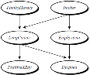--- A set of conditional probability tables (CPTs)

- A (directed acyclic) graphical model of causal influence relationships

--- Represents dependency among the variables

--- Gives a specification of joint probability distribution

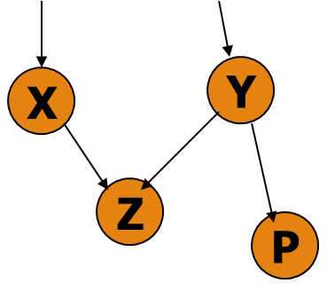

- Nodes: random variables

- Links: dependency

- X and Y are the parents of Z, and Y is the parent of P

- No dependency between Z and P

- Has no loops/cycles

**A Bayesian Network and Some of Its CPTs**

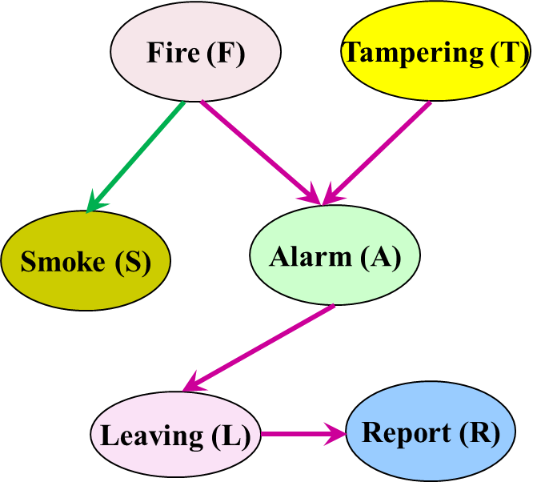 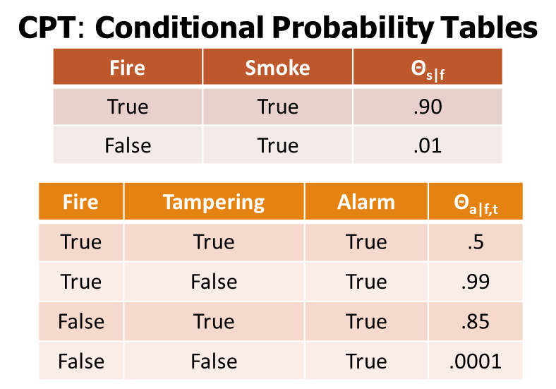

- Derivation of the probability of a particular combination of values of X, from CPT:

- CPT shows the conditional probability for each possible combination of its parents

$$P\left(x_{1},…,x_{n}\right)= \prod_{i=1}^{n}{(x_{i}|Parents\left(x_{i}\right))}$$

**How Are Bayesian Networks Constructed?**

- Subjective construction: Identification of (direct) causal structure --- People are quite good at identifying direct causes from a given set of variables & whether the set contains all relevant direct causes --- Markovian assumption: Each variable becomes independent of its non-effects once its direct causes are known ----- E.g., S ← F → A ← T, path S → A is blocked once we know F → A --- HMM (Hidden Markov Model): often used to model dynamic systems whose states are not observable, yet their outputs are

- Synthesis from other specifications --- E.g., from a formal system design: block diagrams & info flow

- Learning from data (e.g., from medical records or student admission record) --- Learn parameters give its structure or learn both structure and parms --- Maximum likelihood principle: favors Bayesian networks that maximize the probability of observing the given data set

**Training Bayesian Networks: Several Scenarios**

- Scenario 1: Given both the network structure and all variables observable: compute only the CPT entries - Scenario 2: Network structure known, some variables hidden: gradient descent (greedy hill-climbing) method, i.e., search for a solution along the steepest descent of a criterion function --- Weights are initialized to random probability values --- At each iteration, it moves towards what appears to be the best solution at the moment, w.o. backtracking --- Weights are updated at each iteration & converge to local optimum

- Scenario 3: Network structure unknown, all variables observable: search through the model space to reconstruct network topology - Scenario 4: Unknown structure, all hidden variables: No good algorithms known for this purpose

- D. Heckerman. A Tutorial on Learning with Bayesian Networks. In Learning in Graphical Models, M. Jordan, ed. MIT Press, 1999.

**Neural Network for Classification**

- Started by psychologists and neurobiologists to develop and test computational analogues of neurons - A neural network: A set of connected input/output units where each connection has a weight associated with it --- During the learning phase, the network learns by adjusting the weights so as to be able to predict the correct class label of the input tuples - Also referred to as connectionist learning due to the connections between units - Backpropagation: A neural network learning algorithm

**Neuron: A Hidden/Output Layer Unit**

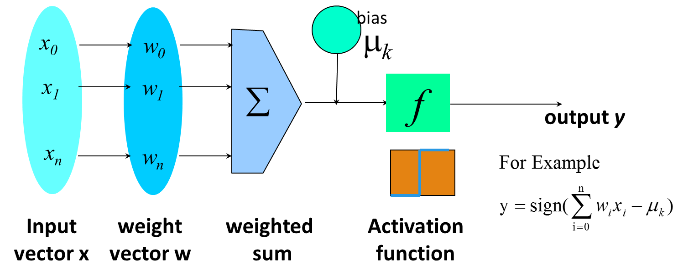

- An n-dimensional input vector x is mapped into variable y by means of the scalar product and a nonlinear function mapping - The inputs to unit are outputs from the previous layer. They are multiplied by their corresponding weights to form a weighted sum, which is added to the bias associated with unit. Then a nonlinear activation function is applied to it.

**A Multi-Layer Feed-Forward Neural Network**

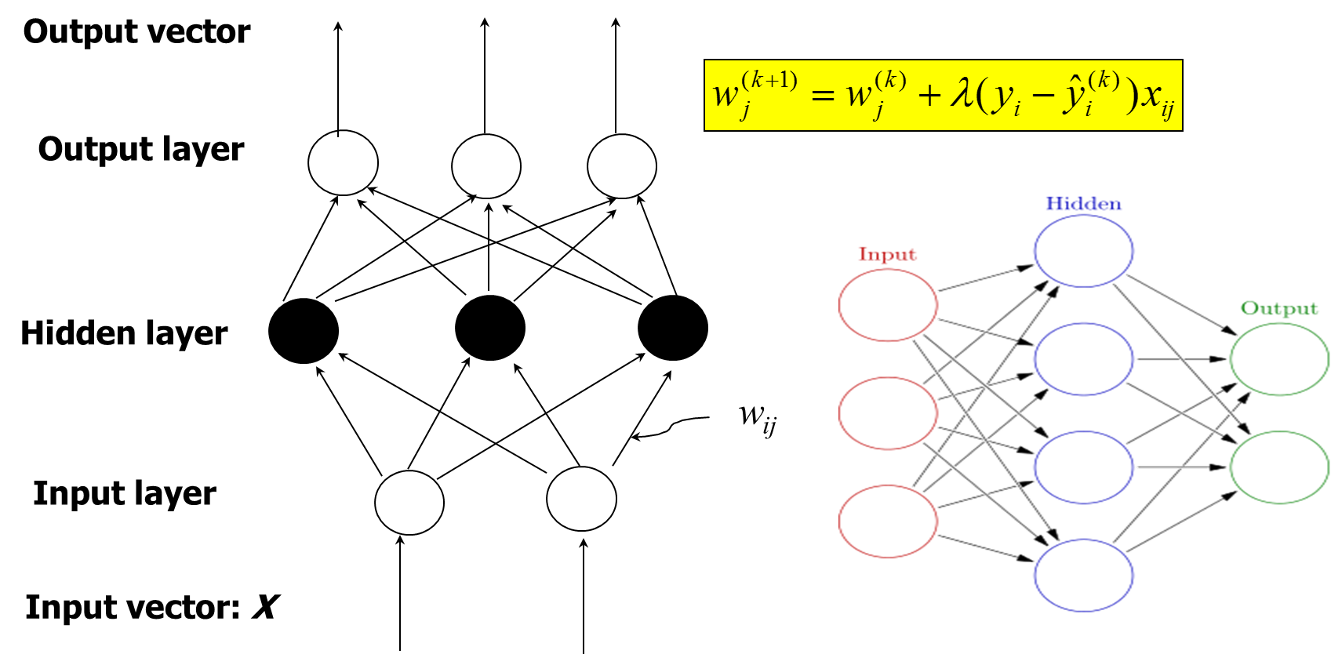

Input Hidden Output

**How a Multi-Layer Neural Network Works**

- The inputs to the network correspond to the attributes measured for each training tuple - Inputs are fed simultaneously into the units making up the input layer - They are then weighted and fed simultaneously to a hidden layer

- The number of hidden layers is arbitrary, although usually only one - The weighted outputs of the last hidden layer are input to units making up the output layer, which emits the network's prediction - The network is feed-forward: None of the weights cycles back to an input unit or to an output unit of a previous layer - From a statistical point of view, networks perform nonlinear regression --- Given enough hidden units and enough training samples, they can closely approximate any function

**Defining a Network Topology**

- Decide the **network topology** --- Specify # of units in the input layer, # of hidden layers (if > 1), # of units in each hidden layer, and # of units in the output layer - Normalize the input values for each attribute measured in the training tuples to [0.0—1.0] - One **input** unit per domain value, each initialized to 0 - **Output**, if for classification and more than two classes, one output unit per class is used - Once a network has been trained and its accuracy is **unacceptable**, repeat the training process with a different network topology or a different set of initial weights

**Back Propagation**

- Back propagation: Reset weights on the "front" neural units and this is sometimes done in combination with training where the correct result is known - Iteratively process a set of training tuples & compare the network's prediction with the actual known target value - For each training tuple, the weights are modified to minimize the mean squared error between the network's prediction and the actual target value

- Modifications are made in the “backwards” direction: from the output layer, through each hidden layer down to the first hidden layer, hence “backpropagation” – Steps --- Initialize weights to small random numbers, associated with biases

--- Propagate the inputs forward (by applying activation function) --- Backpropagate the error (by updating weights and biases) ---Terminating condition (when error is very small, etc.)

**From Neural Networks to Deep Learning**

- Train networks with many layers (vs. shallow nets with just a couple of layers) - Multiple layers work to build an improved feature space --- First layer learns 1st order features (e.g., edges, …) --- 2nd layer learns higher order features (combinations of first layer features, combinations of edges, etc.) --- In current models, layers often learn in an unsupervised mode and discover general features of the input space—serving multiple tasks related to the unsupervised instances (image recognition, etc.) --- Then final layer features are fed into supervised layer(s) ----- And entire network is often subsequently tuned using supervised training of the entire net, using the initial weightings learned in the unsupervised phase --- Could also do fully supervised versions (back-propagation)

**Classification: A Mathematical Mapping**

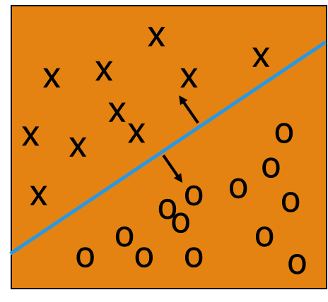- Classification: predicts categorical class labels --- E.g., Personal homepage classification ----- xi = (x1, x2, x3, …), yi = +1 or –1 ----- x1 : # of word “homepage” ----- x2 : # of word “welcome” - Mathematically, x ∈X = ℜn, y ∈ Y = {+1, –1}, --- We want to derive a function f: X 🡪 Y - Linear Classification --- Binary Classification problem

--- Data above the red line belongs to class ‘x’

--- Data below red line belongs to class ‘o’

--- Examples: SVM, Perceptron, Probabilistic Classifiers

**Discriminative Classifiers**

- Advantages --- Prediction accuracy is generally high

----- As compared to Bayesian methods --- Robust, works when training examples contain errors --- Fast evaluation of the learned target function ----- Bayesian networks are normally slow - Criticism --- Long training time --- Difficult to understand the learned function (weights) ----- Bayesian networks can be used easily for pattern discovery --- Not easy to incorporate domain knowledge ----- Easy in the form of priors on the data or distributions

**SVM—Support Vector Machines**

- A relatively new classification method for both linear and nonlinear data - It uses a nonlinear mapping to transform the original training data into a higher dimension - With the new dimension, it searches for the linear optimal separating hyperplane (i.e., “decision boundary”) - With an appropriate nonlinear mapping to a sufficiently high dimension, data from two classes can always be separated by a hyperplane - SVM finds this hyperplane using support vectors (“essential” training tuples) and margins (defined by the support vectors)

**SVM—History and Applications**

- Vapnik and colleagues (1992)—groundwork from Vapnik & Chervonenkis’ statistical learning theory in 1960s - Features: training can be slow but accuracy is high owing to their ability to model complex nonlinear decision boundaries (margin maximization) - Used for: classification and numeric prediction - Applications: --- handwritten digit recognition, object recognition, speaker identification, benchmarking time-series prediction tests

**SVM—General Philosophy/ Margins and Support Vectors**

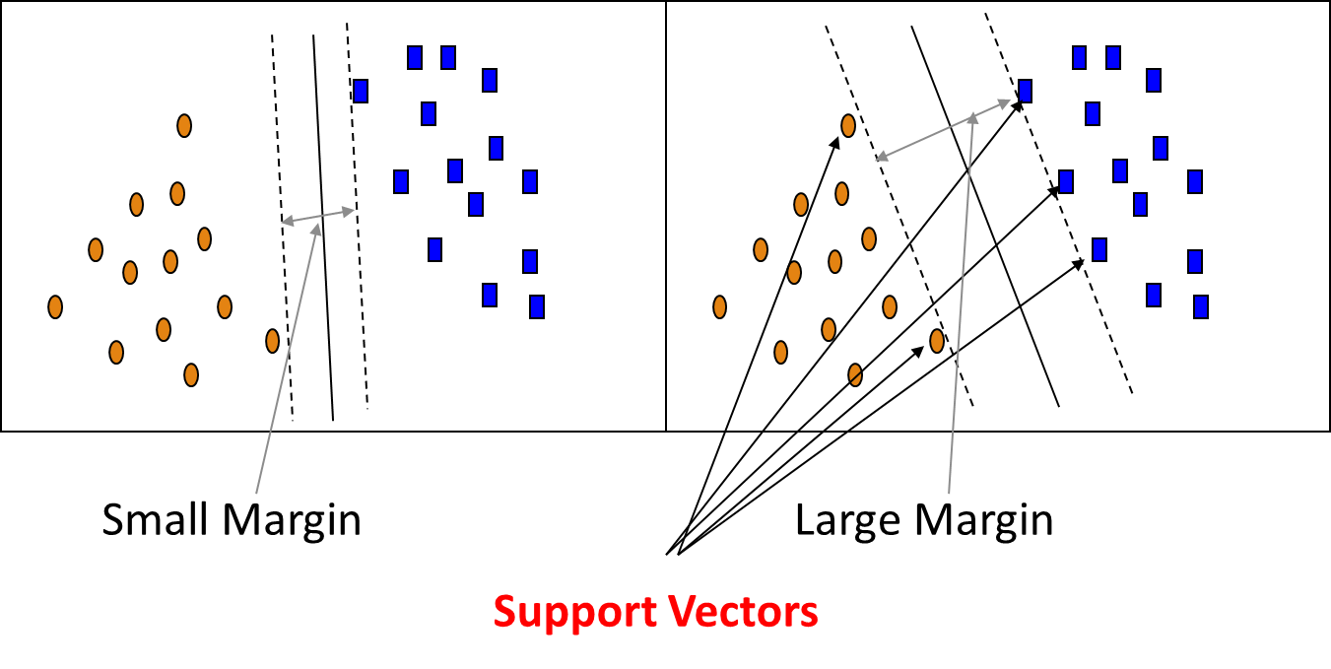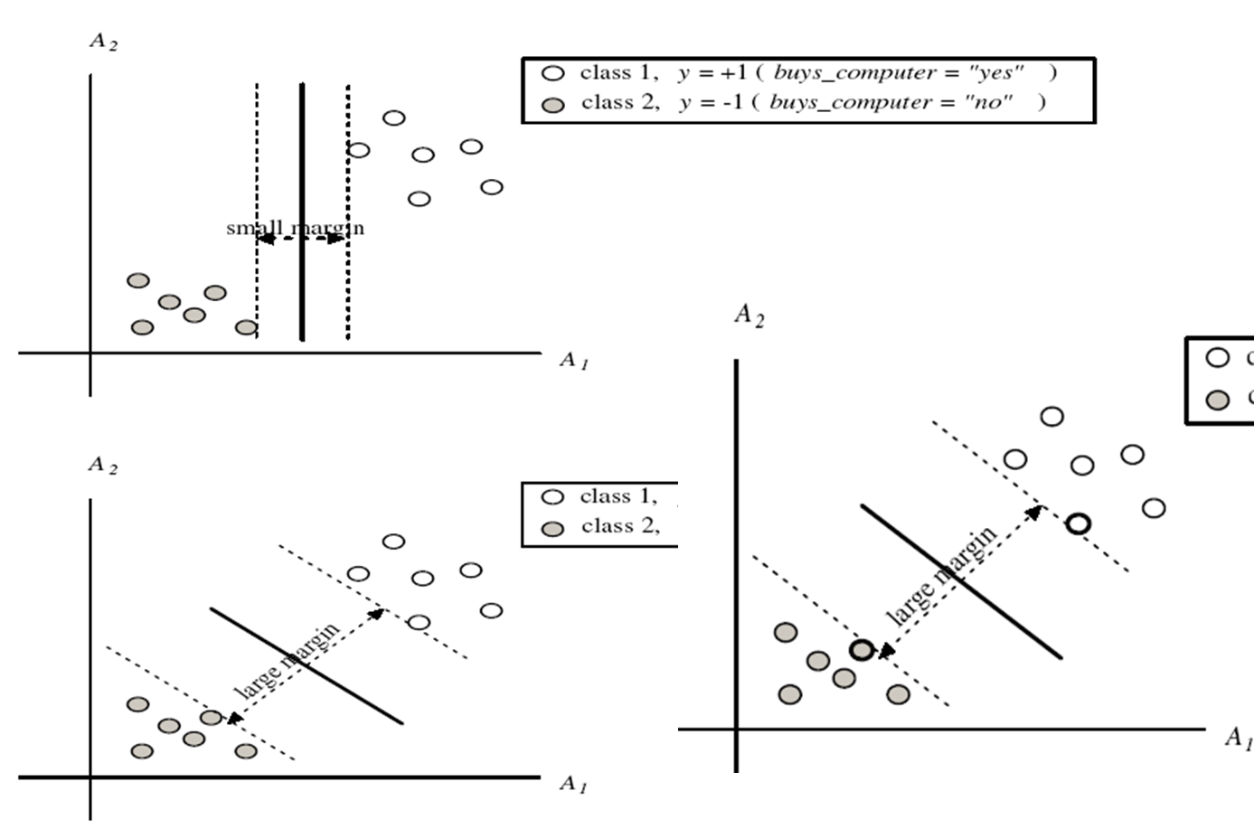

**SVM—When Data Is Linearly Separable**

- Let data D be (X1, y1), …, (X|D|, y|D|), where Xi is the set of training tuples associated with the class labels yi

- There are infinite lines (hyperplanes) separating the two classes but we want to find the best one (the one that minimizes classification error on unseen data)

- SVM searches for the hyperplane with the largest margin, i.e., maximum marginal hyperplane (MMH)

**SVM—Linearly Separable**

- A separating hyperplane can be written as; W ● X + b = 0; where W={w1, w2, …, wn} is a weight vector and b a scalar (bias) - For 2-D it can be written as: w0 + w1 x1 + w2 x2 = 0 - The hyperplane defining the sides of the margin: --- H1: w0 + w1 x1 + w2 x2 ≥ 1 for yi = +1, and --- H2: w0 + w1 x1 + w2 x2 ≤ – 1 for yi = –1 - Any training tuples that fall on hyperplanes H1 or H2 (i.e., the sides defining the margin) are support vectors - This becomes a constrained (convex) quadratic optimization problem: --- Quadratic objective function and linear constraints 🡪 Quadratic Programming (QP) 🡪 Lagrangian multipliers

- Transform the original input data into a higher dimensional space

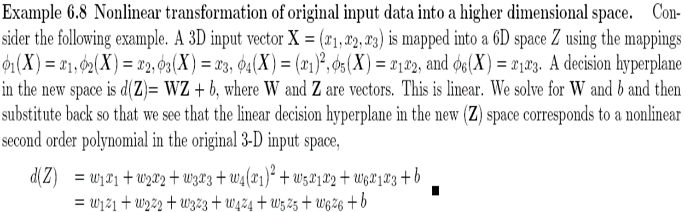

- Search for a linear separating hyperplane in the new space

**Why Is SVM Effective on High Dimensional Data?**

- The complexity of trained classifier is characterized by the # of support vectors rather than the dimensionality of the data

- The support vectors are the essential or critical training examples —they lie closest to the decision boundary (MMH)

- If all other training examples are removed and the training is repeated, the same separating hyperplane would be found

- The number of support vectors found can be used to compute an (upper) bound on the expected error rate of the SVM classifier, which is independent of the data dimensionality

- Thus, an SVM with a small number of support vectors can have good generalization, even when the dimensionality of the data is high

**Kernel Functions for Nonlinear Classification**

- Instead of computing the dot product on the transformed data, it is mathatically equivalent to applying a kernel function K(Xi, Xj) to the original data, i.e., --- K(Xi, Xj) = Φ(Xi) Φ(Xj)

- Typical Kernel Functions

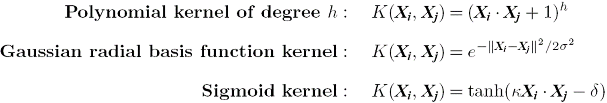

- SVM can also be used for classifying multiple (> 2) classes and for regression analysis (with additional parameters)

**Scaling SVM by Hierarchical Micro-Clustering**

- SVM is not scalable to # of data objects in terms of training time and memory usage - CB-SVM (Clustering-Based SVM): H. Yu, J. Yang, and J. Han, “Classifying Large Data Sets Using SVM with Hierarchical Clusters”, KDD'03 - Clustering-Based SVM: Algorithm outline --- Construct two CF-trees (hierarchical clusters) --- Train an SVM from the centroids of the root entries --- De-cluster the entries near the boundary into the next level ----- The children entries de-clustered from the parent entries are accumulated into the training set with the non-declustered parent entries --- Repeat until nothing is accumulated - At deriving support vectors, de-cluster micro-clusters near “candidate vector” to ensure high classification accuracy

**CF-Tree: Hierarchical Micro-cluster**

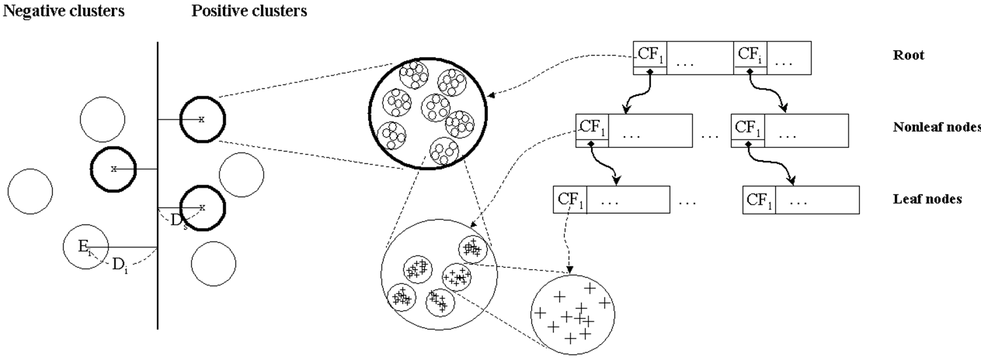

- One scan of the data set: Construct two CF-trees (i.e., statistical summary of the data) from positive and negative data sets independently - Micro-clustering: Hierarchical indexing structure --- Provide finer samples closer to the boundary and coarser samples farther from the boundary

**Selective Declustering: Ensure High Accuracy**

- CF tree is a suitable base structure for selective declustering - De-cluster only the cluster Ei such that --- Di – Ri < Ds, where Di is the distance from the boundary to the center point of Ei and Ri is the radius of Ei --- Decluster only the cluster whose subclusters have possibilities to be the support cluster of the boundary ----- “Support cluster”: The cluster whose centroid is a support vector

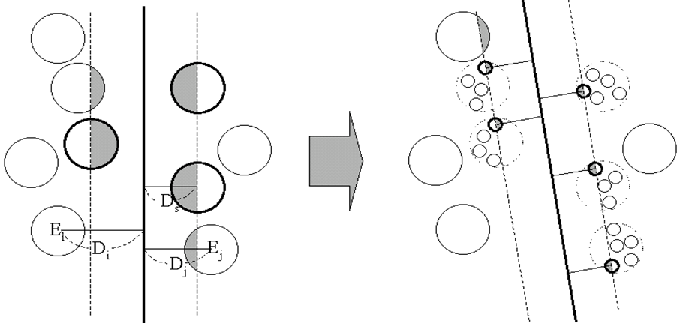

**Accuracy and Scalability on Synthetic Dataset**



- Experiments on large synthetic data sets shows better accuracy than random sampling approaches and far more scalable than the original SVM algorithm

**SVM Related Links**

- SVM Website: <http://www.kernel-machines.org/> - Representative implementations --- LIBSVM: an efficient implementation of SVM, multi-class classifications, nu-SVM, one-class SVM, including also various interfaces with java, python, etc. --- SVM-light: simpler but performance is not better than LIBSVM, support only binary classification and only in C --- SVM-torch: another recent implementation also written in C

**Rule and Pattern-Based Classification**

**Using IF-THEN Rules for Classification**

- Represent the knowledge in the form of IF-THEN rules

R1: IF age = youth AND student = yes THEN buys_computer = yes --- Rule antecedent/precondition vs. rule consequent - Assessment of a rule: coverage and accuracy --- ncovers = # of tuples covered by R1 --- ncorrect = # of tuples correctly classified by R1 --- coverage(R1) = ncovers /|D| /* D: training data set */ --- accuracy(R1) = ncorrect / ncovers

- If more than one rule are triggered, need conflict resolution

--- Size ordering: assign the highest priority to the triggering rules that has the “toughest” requirement (i.e., with the most attribute tests) --- Class-based ordering: decreasing order of prevalence or misclassification cost per class --- Rule-based ordering (decision list): rules are organized into one long priority list, according to some measure of rule quality or by experts

**Rule Extraction from a Decision Tree**

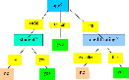- Rules are easier to understand than large trees

- One rule is created for each path from the root to a leaf

- Each attribute-value pair along a path forms a conjunction: the leaf holds the class prediction

- Rules are mutually exclusive and exhaustive

- Example: Rule extraction from our buys_computer decision-tree --- IF age = young AND student = no; THEN buys_computer = no --- IF age = young AND student = yes; THEN buys_computer = yes --- IF age = mid-age; THEN buys_computer = yes --- IF age = old AND credit_rating = excellent THEN buys_computer = no --- IF age = old AND credit_rating = fair; THEN buys_computer = yes

**Rule Induction: Sequential Covering Method**

- Sequential covering algorithm: Extracts rules directly from training data - Typical sequential covering algorithms: FOIL, AQ, CN2, RIPPER - Rules are learned sequentially, each for a given class Ci will cover many tuples of Ci but none (or few) of the tuples of other classes - Steps: --- Rules are learned one at a time --- Each time a rule is learned, the tuples covered by the rules are removed --- Repeat the process on the remaining tuples until termination condition, e.g., when no more training examples or when the quality of a rule returned is below a user-specified threshold - Comp. w. decision-tree induction: learning a set of rules simultaneously

**Sequential Covering Algorithm**

|  |  |
| --- | --- |
| while (enough target tuples left)  generate a rule  remove positive target tuples satisfying this rule | To generate a rule  **while**(true)  find the best predicate *p*  **if** foil-gain(*p*) > threshold **then** add *p* to current rule  **else** break |
|  |  |

**How to Learn-One-Rule?**

- Start with the most general rule possible: condition = empty

- Adding new attributes by adopting a greedy depth-first strategy --- Picks the one that most improves the rule quality

- Rule-Quality measures: consider both coverage and accuracy

--- Foil-gain (in FOIL & RIPPER): assesses info_gain by extending condition

$$FOIL_Gain= pos'×(\log_{2}\frac{pos^{'}}{pos^{'}+neg^{'}}-\log_{2}\frac{pos}{pos+neg})$$

----- favors rules that have high accuracy and cover many positive tuples

- Rule pruning based on an independent set of test tuples

$FOIL_Prune(R)= \frac{pos-neg}{pos+neg}$--- Pos/neg are # of positive/negative tuples covered by R --- If FOIL_Prune is higher for the pruned version of R, prune R

**Pattern-Based Classification, Why?**

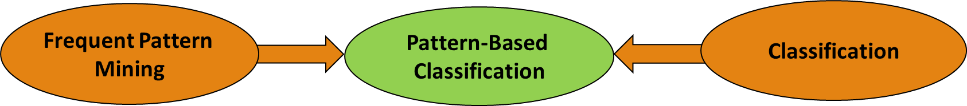

- Pattern-based classification: An integration of both themes

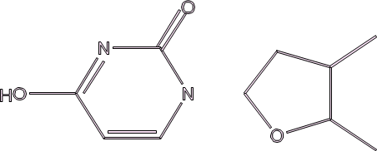- Why pattern-based classification? --- Feature construction ----- Higher order; compact; discriminative ----- E.g., single word → phrase (Apple pie, Apple i-pad) --- Complex data modeling ----- Graphs (no predefined feature vectors) ----- Sequences ----- Semi-structured/unstructured Data

**Pattern-Based Classification on Graphs**

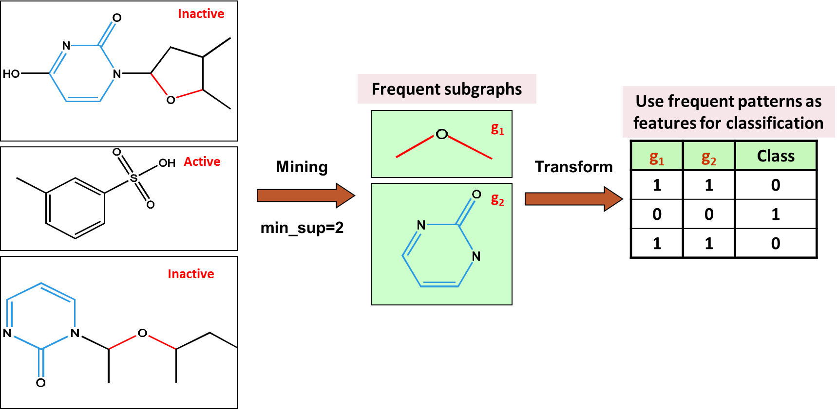

**Associative or Pattern-Based Classification**

- Data: Transactions, microarray data, … → Patterns or association rules - Classification Methods (Some interesting work): --- CBA [Liu, Hsu & Ma, KDD’98]: Use high-conf., high-support class association rules to build classifiers --- Emerging patterns [Dong & Li, KDD’99]: Patterns whose support changes significantly between the two classes --- CMAR [Li, Han & Pei, ICDM’01]: Multiple rules in prediction --- CPAR [Yin & Han, SDM’03]: Beam search on multiple prediction rules --- RCBT [Cong et al., SIGMOD’05]: Build classifier based on mining top-k covering rule groups with row enumeration (for high-dimensional data) --- Lazy classifier [Veloso, Meira & Zaki, ICDM’06]: For a test t, project training data D on t, mine rules from Dt , predict on the best rule --- Discriminative pattern-based classification [Cheng et al., ICDE’07]

**CBA: Classification Based on Associations**

- CBA [Liu, Hsu and Ma, KDD’98]

- Method --- Mine high-confidence, high-support class association rules --- LHS: conjunctions of attribute-value pairs); RHS: class labels ----- p1 ^ p2 … ^ pl 🡪 “Aclass-label = C” (confidence, support) --- Rank rules in descending order of confidence and support --- Classification: Apply the first rule that matches a test case; o.w. apply the default rule --- Effectiveness: Often found more accurate than some raditional classification methods, such as C4.5 --- Why? — Exploring high confident associations among multiple attributes may overcome some constraints introduced by some classifiers that consider only one attribute at a time

**CMAR: Classification Based on Multiple Association Rules**

- Rule pruning whenever a rule is inserted into the tree

--- Given two rules, R1 and R2, if the antecedent of R1 is more general than that of R2 and conf(R1) ≥ conf(R2), then prune R2 --- Prunes rules for which the rule antecedent and class label are not positively correlated, based on the χ2 test of statistical significance - Classification based on generated /pruned rules --- If only one rule satisfies tuple X, assign the class label of the rule --- If a rule set S satisfies X ----- Divide S into groups according to class labels ----- Use a weighted χ2 measure to find the strongest group of rules, based on the statistical correlation of rules within a group ----- Assign X the class label of the strongest group - CMAR improves model construction efficiency and classification accuracy

**Discriminative Pattern-Based Classification**

- Discriminative patterns as features for classification [Cheng et al., ICDE’07] - Principle: Mining discriminative frequent patterns as high-quality features and then apply any classifier

- Framework (PatClass) --- Feature construction by frequent itemset mining --- Feature selection (e.g., using Maximal Marginal Relevance (MMR)) ----- Select discriminative features (i.e., that are relevant but minimally similar to the previously selected ones) ----- Remove redundant or closely correlated features --- Model learning ----- Apply a general classifier, such as SVM or C4.5, to build a classification model

**On the Power of Discriminative Patterns**

- K-itemsets are often more informative than single features (1-itemsets) in classification - Computation on real datasets shows: The discriminative power of k-itemsets (for k > 1 but often ≤ 10) is higher than that of single features

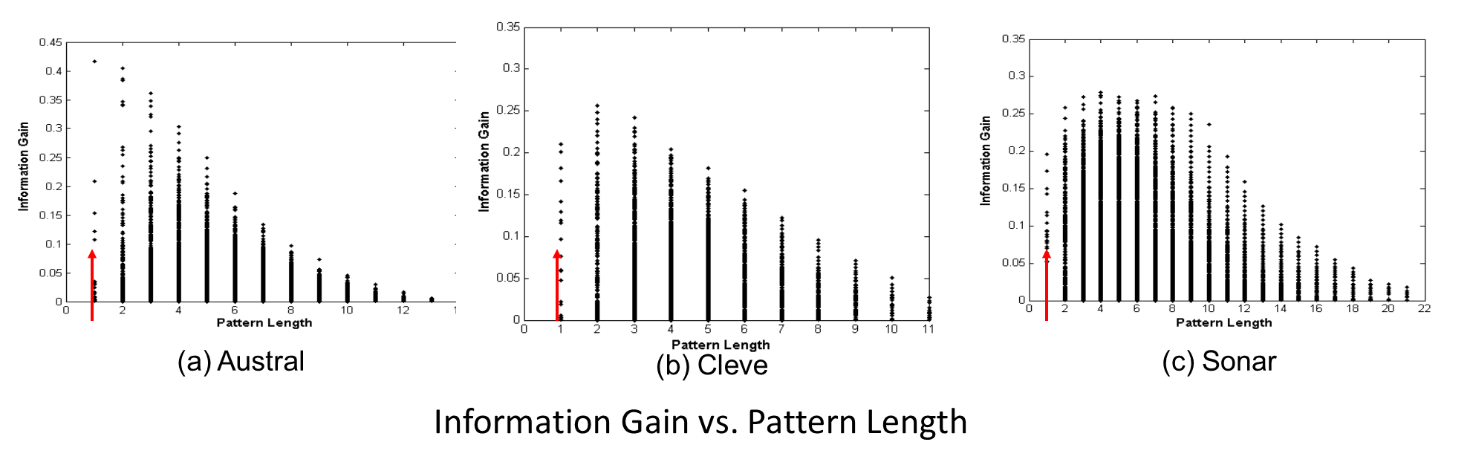

**Information Gain vs. Pattern Frequency**

- Computation on real datasets shows: Pattern frequency (but not too frequent) is strongly tied with the discriminative power (information gain) - Information gain upper bound monotonically increases with pattern frequency

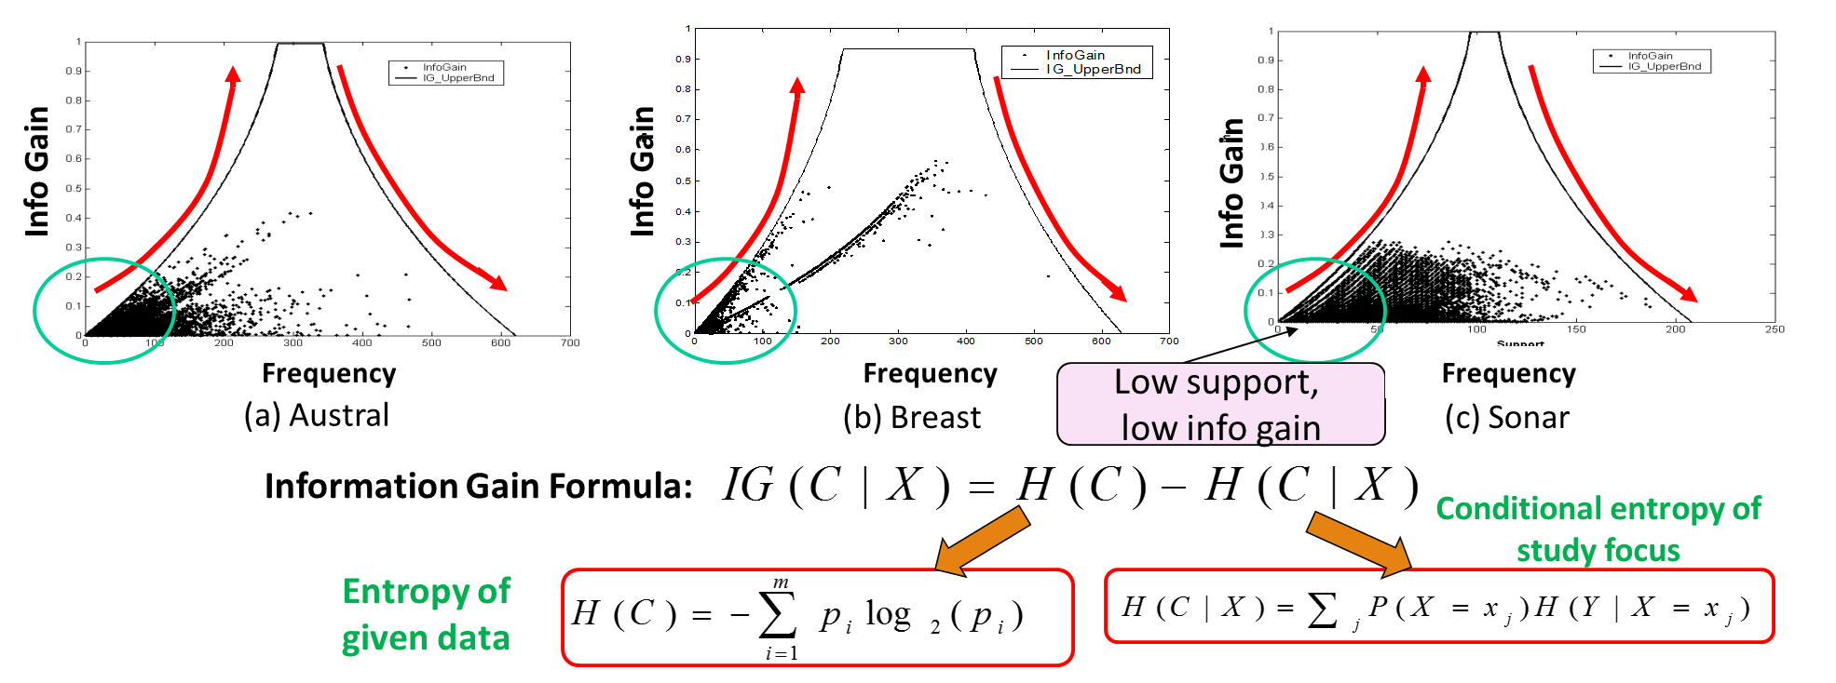

**Mining Concise Set of Discriminative Patterns**

Frequent pattern mining, then getting discriminative patterns: Expensive, large model

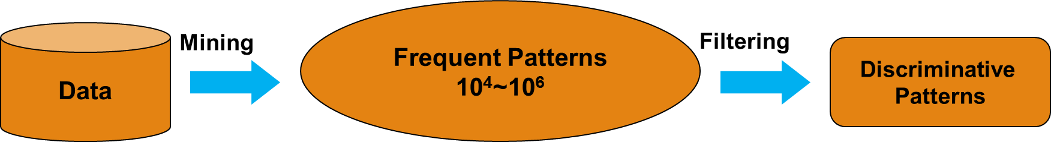

DDPMine [Cheng et al., ICDE’08]: Direct mining of discriminative patterns: Efficient

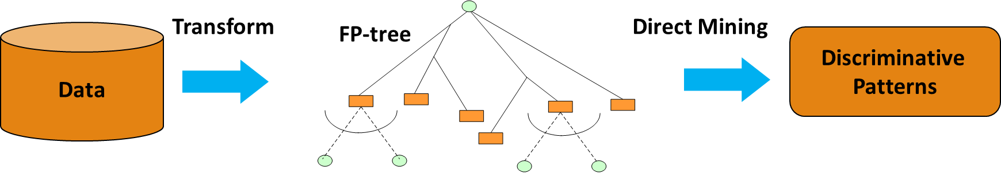

DPClass [Shang et al, SDM’16]: A better solution—Efficient, effective, and generating a very limited number of (such as only 20 or so) patterns

**DPClass: Discriminative Pattern-based Classification**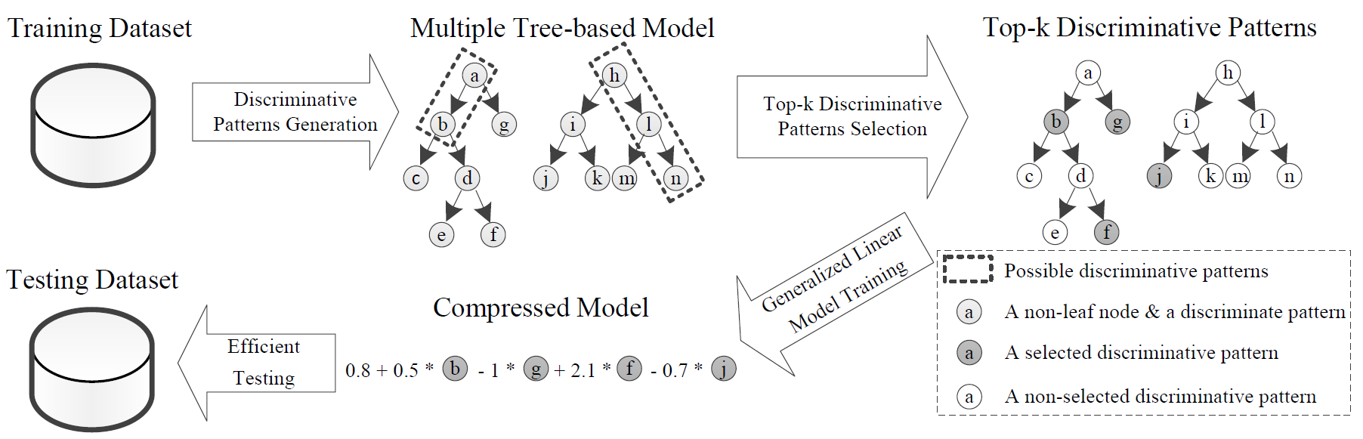

Input: A feature table for training data

- Adopt every prefix path in an (extremely) random forest as a candidate pattern --- The split points of continuous variables are automatically chosen by random forest 🡪 No discretization! - Run top-k (e.g., top-20) pattern selection based on training data - Train a generalized linear model (e.g., logistic regression) based on “bag-of-patterns” representations of training data

**Explanatory Discriminative Patterns: Generation**

- Example: For each patient, we have several uniformly sampled features as follows --- Age (A): Positive Integers no more than 60 --- Gender (G): Male or Female. --- Lab Test 1 (LT1): Categorical values from (A, B, O, AB) --- Lab Test 2 (LT2): Continuous values in [0..1] - The positive label of the hypo-disease will be given when at least one of the following rules holds --- (age > 18) and (gender = Male) and (LT1 = AB) and (LT2 ≥ 0.6) --- (age > 18) and (gender = Female) and (LT1 = O) and (LT2 ≥ 0.5) --- (age ≤ 18) and (LT2 ≥ 0.9) - Training: 〖10〗^5 random patients + 0.1% noise --- Flip the binary labels with 0.1% probability - Testing: 5×〖10〗^4 random patients in test

**Explanatory Discriminative Patterns: Evaluation**

- Accuracy: --- DPClass 99.99% (perfect) --- DDPMine 95.64% (reasonable) -Top-3 Discriminative Patterns:

--- DPClass (perfect): ----- (age > 18) and (gender = Female) and (LT1 = O) and (LT2 ≥ 0.496) ----- (age ≤ 18) and (LT2 ≥ 0.900) ----- (age > 18) and (gender = Male) and (LT1 = AB) and (LT2 ≥ 0.601) --- DDPMine (poor): (LT2 > 0.8)

----- (gender = Male) and (LT1 = AB) and (LT2 ≥ 0.6) and (LT2 < 0.8) ----- (gender = Female) and (LT1 = O) and (LT2 ≥ 0.6) and (LT2 < 0.8)

**Lazy vs. Eager Learning**

- Lazy vs. eager learning --- Lazy learning (e.g., instance-based learning): Simply stores training data (or only minor processing) and waits until it is given a test tuple --- Eager learning (the above discussed methods): Given a set of training tuples, constructs a classification model before receiving new (e.g., test) data to classify - Lazy: less time in training but more time in predicting – Accuracy: --- Lazy method effectively uses a richer hypothesis space since it uses many local linear functions to form an implicit global approximation to the target function --- Eager: must commit to a single hypothesis that covers the entire instance space

**Lazy Learner: Instance-Based Methods**

- Instance-based learning: --- Store training examples and delay the processing (“lazy evaluation”) until a new instance must be classified - Typical approaches --- k-nearest neighbor approach ----- Instances represented as points in a Euclidean space. --- Locally weighted regression ----- Constructs local approximation --- Case-based reasoning ----- Uses symbolic representations and knowledge-based inference

**The *k*-Nearest Neighbor Algorithm**

- All instances correspond to points in the n-D space - The nearest neighbor are defined in terms of Euclidean distance, dist(X1, X2) - Target function could be discrete- or real- valued - For discrete-valued, k-NN returns the most common value among the k training examples nearest to xq - Vonoroi diagram: the decision surface induced by 1-NN for a typical set of training examples

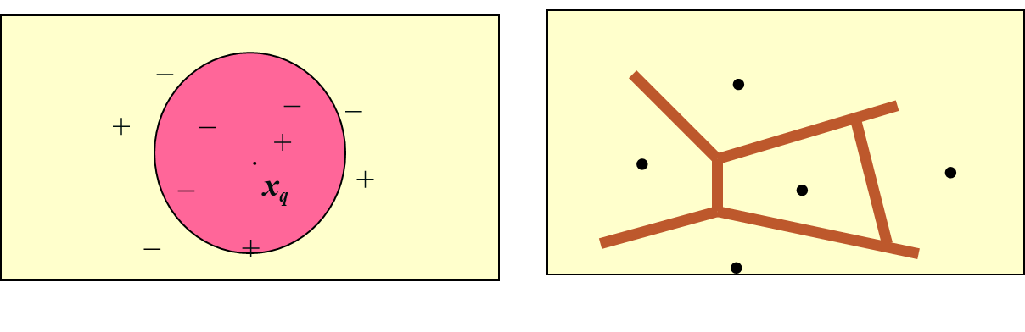

**Discussion on the *k*-NN Algorithm**

- k-NN for real-valued prediction for a given unknown tuple --- Returns the mean values of the k nearest neighbors - Distance-weighted nearest neighbor algorithm --- Weight the contribution of each of the k neighbors according to their distance to the query xq ----- Give greater weight to closer neighbors $w ≡ \frac{1}{d{(x_{q},x_{i})}^{2}}$- Robust to noisy data by averaging k-nearest neighbors - Curse of dimensionality: distance between neighbors could be dominated by irrelevant attributes

--- To overcome it, axes stretch or elimination of the least relevant attributes

**Case-Based Reasoning (CBR)**

- CBR: Uses a database of problem solutions to solve new problems - Store symbolic description (tuples or cases)—not points in a Euclidean space - Applications: Customer-service (product-related diagnosis), legal ruling – Methodology --- Instances represented by rich symbolic descriptions (e.g., function graphs) --- Search for similar cases, multiple retrieved cases may be combined --- Tight coupling between case retrieval, knowledge-based reasoning, and problem solving – Challenges --- Find a good similarity metric

--- Indexing based on syntactic similarity measure, and when failure, backtracking, and adapting to additional cases

Other Classification Methods: Genetic Algorithms, Fuzzy Sets and Rough Sets

**Genetic Algorithms (GA)**

- Genetic Algorithm: based on an analogy to biological evolution - An initial population is created consisting of randomly generated rules --- Each rule is represented by a string of bits --- E.g., if A1 and ¬A2 then C2 can be encoded as 100 --- If an attribute has k > 2 values, k bits can be used - Based on the notion of survival of the fittest, a new population is formed to consist of the fittest rules and their offspring - The fitness of a rule is represented by its classification accuracy on a set of training examples - Offspring are generated by crossover and mutation - The process continues until a population P evolves when each rule in P satisfies a pre-specified threshold - Slow but easily parallelizable

**Rough Set Approach**

- Rough sets are used to approximately or “roughly” define equivalent classes - A rough set for a given class C is approximated by two sets: a lower approximation (certain to be in C) and an upper approximation (cannot be described as not belonging to C) - Finding the minimal subsets (reducts) of attributes for feature reduction is NP-hard but a discernibility matrix (which stores the differences between attribute values for each pair of data tuples) is used to reduce the computation intensity

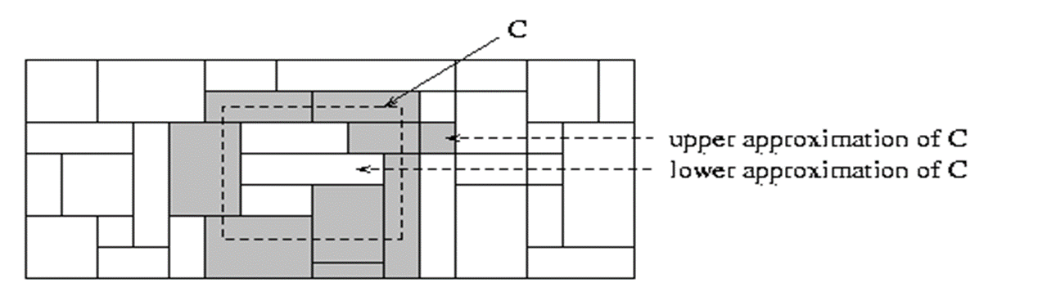

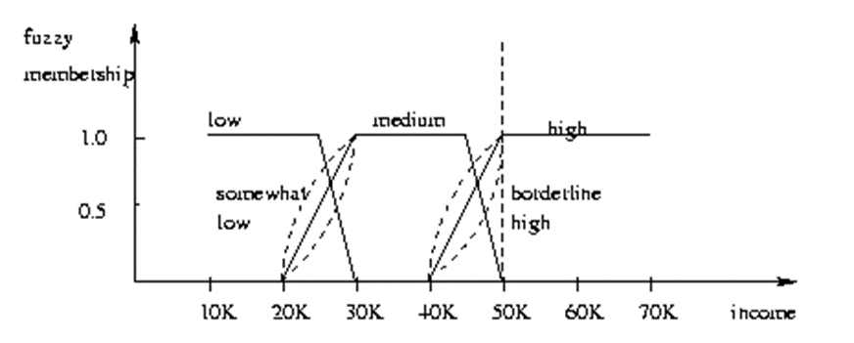**Fuzzy Set Approaches**

- Fuzzy logic uses truth values between 0.0 and 1.0 to represent the degree of membership (such as in a fuzzy membership graph)

- Attribute values are converted to fuzzy values. Ex.:

--- Income, x, is assigned a fuzzy membership value to each of the discrete categories {low, medium, high}, e.g. $49K belongs to “medium income” with fuzzy value 0.15 but belongs to “high income” with fuzzy value 0.96 --- Fuzzy membership values do not have to sum to 1. - Each applicable rule contributes a vote for membership in the categories - Typically, the truth values for each predicted category are summed, and these sums are combined

**Multiclass Classification**

- Classification involving more than two classes (i.e., > 2 Classes) - Method 1. One-vs.-all (OVA): Learn a classifier one at a time --- Given m classes, train m classifiers: one for each class --- Classifier j: treat tuples in class j as positive & all others as negative --- To classify a tuple X, the set of classifiers vote as an ensemble - Method 2. All-vs.-all (AVA): Learn a classifier for each pair of classes --- Given m classes, construct m(m-1)/2 binary classifiers --- A classifier is trained using tuples of the two classes --- To classify a tuple X, each classifier votes ----- X is assigned to the class with maximal vote - Comparison

--- All-vs.-all tends to be superior to one-vs.-all --- Problem: Binary classifier is sensitive to errors, and errors affect vote count

**Error-Correcting Codes for Multiclass Classification**

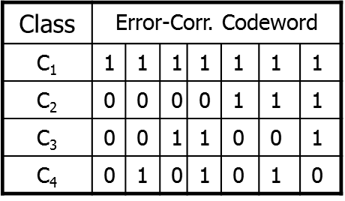- Originally designed to correct errors during data transmission for communication tasks by exploring data redundancy

- Example 0 --- A 7-bit codeword associated with classes 1-4 --- Given a unknown tuple X, the 7-trained classifiers output: 0001010 --- Hamming distance: # of different bits between two codewords --- H(X, C1) = 5, by checking # of bits between [1111111] & [0001010] --- H(X, C2) = 3, H(X, C3) = 3, H(X, C4) = 1, thus C4 as the label for X - Error-correcting codes can correct up to (h ̶ 1)/2 1-bit error, where h is the minimum Hamming distance between any two codewords - If we use 1-bit per class, it is equiv. to one-vs.-all approach, the code are insufficient to self-correct - When selecting error-correcting codes, there should be good row-wise and col.-wise separation between the codewords

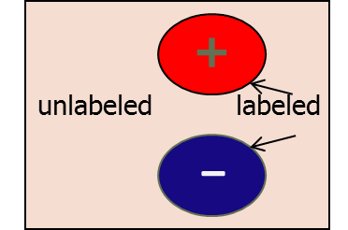**Semi-Supervised Classification**

- Semi-supervised: Uses labeled and unlabeled data to build a classifier - Self-training: --- Build a classifier using the labeled data --- Use it to label the unlabeled data, and those with the most confident label prediction are added to the set of labeled data --- Repeat the above process --- Adv: easy to understand; disadv: may reinforce errors - Co-training: Use two or more classifiers to teach each other --- Each learner uses a mutually independent set of features of each tuple to train a good classifier, say f1 --- Then f1 and f2 are used to predict the class label for unlabeled data X --- Teach each other: The tuple having the most confident prediction from f1 is added to the set of labeled data for f2 & vice versa - Other methods, e.g., joint probability distribution of features and labels

**Active Learning**

- Class labels are expensive to obtain - Active learner: query human (oracle) for labels - Pool-based approach: Uses a pool of unlabeled data --- L: a small subset of D is labeled, U: a pool of unlabeled data in D --- Use a query function to carefully select one or more tuples from U and request labels from an oracle (a human annotator) --- The newly labeled samples are added to L, and learn a model --- Goal: Achieve high accuracy using as few labeled data as possible - Evaluated using learning curves: Accuracy as a function of the number of instances queried (# of tuples to be queried should be small) - Research issue: How to choose the data tuples to be queried? --- Uncertainty sampling: choose the least certain ones --- Reduce version space, the subset of hypotheses consistent w. the training data --- Reduce expected entropy over U: Find the greatest reduction in the total number of incorrect predictions

**Transfer Learning: Conceptual Framework**

- Transfer learning: Extract knowledge from one or more source tasks and apply the knowledge to a target task - Traditional learning: Build a new classifier for each new task - Transfer learning: Build new classifier by applying existing knowledge learned from source tasks

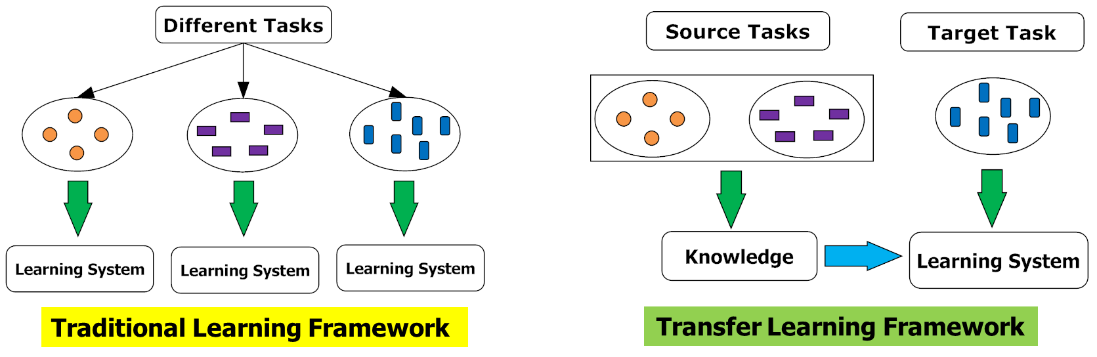

**Transfer Learning: Methods and Applications**

- Applications: Especially useful when data is outdated or distribution changes, e.g., Web document classification, e-mail spam filtering - Instance-based transfer learning: Reweight some of the data from source tasks and use it to learn the target task - TrAdaBoost (Transfer AdaBoost) --- Assume source and target data each described by the same set of attributes (features) & class labels, but rather diff. distributions --- Require only labeling a small amount of target data --- Use source data in training: When a source tuple is misclassified, reduce the weight of such tupels so that they will have less effect on the subsequent classifier - Research issues --- Negative transfer: When it performs worse than no transfer at all --- Heterogeneous transfer learning: Transfer knowledge from different feature space or multiple source domains --- Large-scale transfer learning

**Cluster Analysis: An Introduction**

**What Is Cluster Analysis?**

- What is a cluster? --- A cluster is a collection of data objects which are ----- Similar (or related) to one another within the same group (i.e., cluster)----- Dissimilar (or unrelated) to the objects in other groups (i.e., clusters) - Cluster analysis (or clustering, data segmentation, …) --- Given a set of data points, partition them into a set of groups (i.e., clusters) which are as similar as possible - Cluster analysis is unsupervised learning (i.e., no predefined classes) --- This contrasts with classification (i.e., supervised learning) - Typical ways to use/apply cluster analysis --- As a stand-alone tool to get insight into data distribution, or --- As a preprocessing (or intermediate) step for other algorithms

**What Is Good Clustering?**

- A good clustering method will produce high quality clusters which should have --- High intra-class similarity: Cohesive within clusters --- Low inter-class similarity: Distinctive between clusters - Quality function --- There is usually a separate “quality” function that measures the “goodness” of a cluster --- It is hard to define “similar enough” or “good enough” ----- The answer is typically highly subjective - There exist many similarity measures and/or functions for different applications - Similarity measure is critical for cluster analysis

**Cluster Analysis: Applications**

- A key intermediate step for other data mining tasks --- Generating a compact summary of data for classification, pattern discovery, hypothesis generation and testing, etc. --- Outlier detection: Outliers—those “far away” from any cluster - Data summarization, compression, and reduction --- Ex. Image processing: Vector quantization - Collaborative filtering, recommendation systems, or customer segmentation --- Find like-minded users or similar products

- Dynamic trend detection --- Clustering stream data and detecting trends and patterns - Multimedia data analysis, biological data analysis and social network analysis --- Ex. Clustering images or video/audio clips, gene/protein sequences, etc.

**Considerations for Cluster Analysis**

- Partitioning criteria --- Single level vs. hierarchical partitioning (often, multi-level hierarchical partitioning is desirable, e.g., grouping topical terms) - Separation of clusters --- Exclusive (e.g., one customer belongs to only one region) vs. non-exclusive (e.g., one document may belong to more than one class) - Similarity measure --- Distance-based (e.g., Euclidean, road network, vector) vs. connectivity-based (e.g., density or contiguity) - Clustering space --- Full space (often when low dimensional) vs. subspaces (often in high-dimensional clustering)

**Requirements and Challenges**

- Quality --- Ability to deal with different types of attributes: Numerical, categorical, text, multimedia, networks, and mixture of multiple types --- Discovery of clusters with arbitrary shape --- Ability to deal with noisy data – Scalability --- Clustering all the data instead of only on samples --- High dimensionality --- Incremental or stream clustering and insensitivity to input order - Constraint-based clustering --- User-given preferences or constraints; domain knowledge; user queries - Interpretability and usability

**Cluster Analysis: A Multi-Dimensional Categorization**

- Technique-Centered --- Distance-based methods --- Density-based and grid-based methods --- Probabilistic and generative models --- Leveraging dimensionality reduction methods --- High-dimensional clustering --- Scalable techniques for cluster analysis - Data Type-Centered --- Clustering numerical data, categorical data, text data, multimedia data, time-series data, sequences, stream data, networked data, uncertain data - Additional Insight-Centered --- Visual insights, semi-supervised, ensemble-based, validation-based

**Typical Clustering Methodologies**

- Distance-based methods --- Partitioning algorithms: K-Means, K-Medians, K-Medoids --- Hierarchical algorithms: Agglomerative vs. divisive methods - Density-based and grid-based methods --- Density-based: Data space is explored at a high-level of granularity and then post-processing to put together dense regions into an arbitrary shape --- Grid-based: Individual regions of the data space are formed into a grid-like structure - Probabilistic and generative models: Modeling data from a generative process --- Assume a specific form of the generative model (e.g., mixture of Gaussians) --- Model parameters are estimated with the Expectation-Maximization (EM) algorithm (using the available dataset, for a maximum likelihood fit) --- Then estimate the generative probability of the underlying data points

- High-dimensional clustering --- Subspace clustering: Find clusters on various subspaces ----- Bottom-up, top-down, correlation-based methods vs. δ-cluster methods --- Dimensionality reduction: A vertical form (i.e., columns) of clustering ----- Columns are clustered; may cluster rows and columns together (co-clustering) --- Probabilistic latent semantic indexing (PLSI) then LDA: Topic modeling of text data ----- A cluster (i.e., topic) is associated with a set of words (i.e., dimensions) and a set of documents (i.e., rows) simultaneously --- Nonnegative matrix factorization (NMF) (as one kind of co-clustering) ----- A nonnegative matrix A (e.g., word frequencies in documents) can be approximately factorized two non-negative low rank matrices U and V --- Spectral clustering: Use the spectrum of the similarity matrix of the data to perform dimensionality reduction for clustering in fewer dimensions

**Clustering Different Types of Data**

- Numerical data --- Most earliest clustering algorithms were designed for numerical data - Categorical data (including binary data) --- Discrete data, no natural order (e.g., sex, race, zip-code, and market-basket) - Text data: Popular in social media, Web, and social networks --- Features: High-dimensional, sparse, value corresponding to word frequencies --- Methods: Combination of k-means and agglomerative; topic modeling; co-clustering - Multimedia data: Image, audio, video (e.g., on Flickr, YouTube) --- Multi-modal (often combined with text data) --- Contextual: Containing both behavioral and contextual attributes ----- Images: Position of a pixel represents its context, value represents its behavior ----- Video and music data: Temporal ordering of records represents its meaning

- Time-series data: Sensor data, stock markets, temporal tracking, forecasting, etc. --- Data are temporally dependent --- Time: contextual attribute; data value: behavioral attribute --- Correlation-based online analysis (e.g., online clustering of stock to find stock tickers) --- Shape-based offline analysis (e.g., cluster ECG based on overall shapes) - Sequence data: Weblogs, biological sequences, system command sequences --- Contextual attribute: Placement (rather than time) --- Similarity functions: Hamming distance, edit distance, longest common subsequence --- Sequence clustering: Suffix tree; generative model (e.g., Hidden Markov Model) - Stream data:

--- Real-time, evolution and concept drift, single pass algorithm --- Create efficient intermediate representation, e.g., micro-clustering

- Graphs and homogeneous networks --- Every kind of data can be represented as a graph with similarity values as edges --- Methods: Generative models; combinatorial algorithms (graph cuts); spectral methods; non-negative matrix factorization methods - Heterogeneous networks --- A network consists of multiple typed nodes and edges (e.g., bibliographical data) --- Clustering different typed nodes/links together (e.g., NetClus) - Uncertain data: Noise, approximate values, multiple possible values --- Incorporation of probabilistic information will improve the quality of clustering - Big data: Model systems may store and process very big data (e.g., weblogs) --- Ex. Google’s MapReduce framework ----- Use Map function to distribute the computation across different machines ----- Use Reduce function to aggregate results obtained from the Map step

**User Insights and Interactions in Clustering**

- Visual insights: One picture is worth a thousand words --- Human eyes: High-speed processor linking with a rich knowledge-base --- A human can provide intuitive insights; HD-eye: visualizing HD clusters - Semi-supervised insights: Passing user’s insights or intention to system --- User-seeding: A user provides a number of labeled examples, approximately representing categories of interest - Multi-view and ensemble-based insights --- Multi-view clustering: Multiple clusterings represent different perspectives --- Multiple clustering results can be ensembled to provide a more robust solution - Validation-based insights: Evaluation of the quality of clusters generated --- May use case studies, specific measures, or pre-existing labels

Partitioning Methods

**Partitioning Algorithms: Basic Concepts**

- Partitioning method: Discovering the groupings in the data by optimizing a specific objective function and iteratively improving the quality of partitions - K-partitioning method: Partitioning a dataset D of n objects into a set of K clusters so that an objective function is optimized (e.g., the sum of squared distances is minimized, where ck is the centroid or medoid of cluster Ck) --- A typical objective function: Sum of Squared Errors (SSE)

- Problem definition: Given K, find a partition of K clusters that optimizes the chosen partitioning criterion --- Global optimal: Needs to exhaustively enumerate all partitions --- Heuristic methods (i.e., greedy algorithms): K-Means, K-Medians, K-Medoids, etc.

**The *K-Means* Clustering Method**

- K-Means (MacQueen’67, Lloyd’57/’82) --- Each cluster is represented by the center of the cluster - Given K, the number of clusters, the K-Means clustering algorithm is outlined as follows

--- Select K points as initial centroids --- Repeat ----- Form K clusters by assigning each point to its closest centroid ----- Re-compute the centroids (i.e., mean point) of each cluster --- Until convergence criterion is satisfied - Different kinds of measures can be used

--- Manhattan distance (L1 norm), Euclidean distance (L2 norm), Cosine similarity

**Example: *K-Means* Clustering**

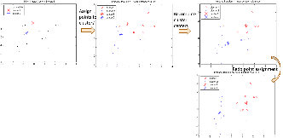

***Execution of the K-Means* Clustering Algorithm**

- Select K points as initial centroids

- Repeat --- Form K clusters by assigning each point to its closest centroid --- Re-compute the centroids (i.e., mean point) of each cluster

- Until convergence criterion is satisfied

**Discussion on the *K-Means* Method**

- Efficiency: O(tKn) where n: # of objects, K: # of clusters, and t: # of iterations --- Normally, K, t << n; thus, an efficient method - K-means clustering often terminates at a local optimal --- Initialization can be important to find high-quality clusters - Need to specify K, the number of clusters, in advance --- There are ways to automatically determine the “best” K --- In practice, one often runs a range of values and selected the “best” K value - Sensitive to noisy data and outliers --- Variations: Using K-medians, K-medoids, etc. - K-means is applicable only to objects in a continuous n-dimensional space

--- Using the K-modes for categorical data - Not suitable to discover clusters with non-convex shapes --- Using density-based clustering, kernel K-means, etc.

**Variations of *K-Means***

- There are many variants of the K-Means method, varying in different aspects --- Choosing better initial centroid estimates ----- K-means++, Intelligent K-Means, Genetic K-Means --- Choosing different representative prototypes for the clusters ----- K-Medoids, K-Medians, K-Modes --- Applying feature transformation techniques ----- Weighted K-Means, Kernel K-Means

**Initialization of K-Means**

- Different initializations may generate rather different clustering results (some could be far from optimal) - Original proposal (MacQueen’67): Select K seeds randomly --- Need to run the algorithm multiple times using different seeds - There are many methods proposed for better initialization of *k* seeds --- K-Means++ (Arthur & Vassilvitskii’07): ----- The first centroid is selected at random ----- The next centroid selected is the one that is farthest from the currently selected (selection is based on a weighted probability score) ----- The selection continues until *K* centroids are obtained

**Example: Poor Initialization May Lead to Poor Clustering**

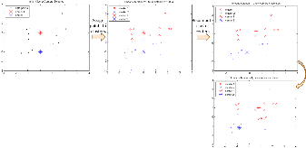

- Rerun of the *K-Means* using another random *K* seeds

- This run of *K*-Means generates a poor quality clustering

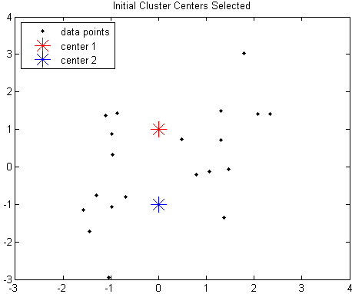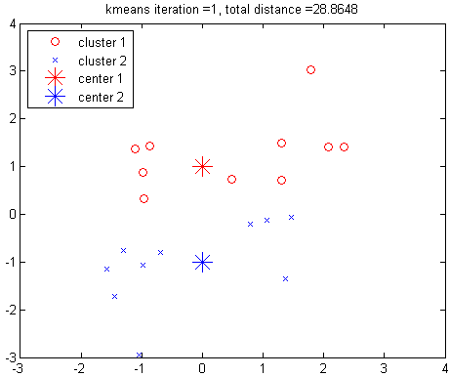

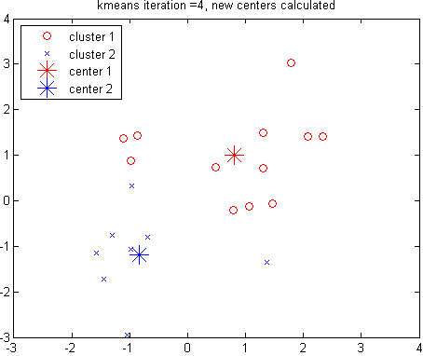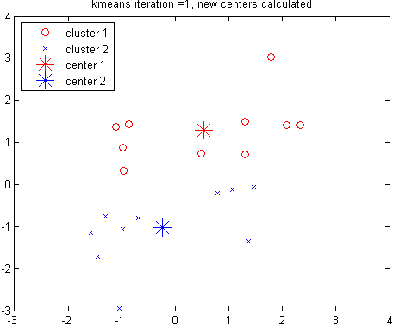

Recompute cluster centers

Assign points to clusters

**Handling Outliers: From *K-Means* to *K-Medoids***

- The K-Means algorithm is sensitive to outliers!—since an object with an extremely large value may substantially distort the distribution of the data - K-Medoids: Instead of taking the mean value of the object in a cluster as a reference point, medoids can be used, which is the most centrally located object in a cluster - The K-Medoids clustering algorithm: --- Select K points as the initial representative objects (i.e., as initial K medoids) --- Repeat ----- Assigning each point to the cluster with the closest medoid ----- Randomly select a non-representative object oi ----- Compute the total cost S of swapping the medoid m with oi ----- If S < 0, then swap m with oi to form the new set of medoids --- Until convergence criterion is satisfied

**PAM: A Typical *K-Medoids* Algorithm**

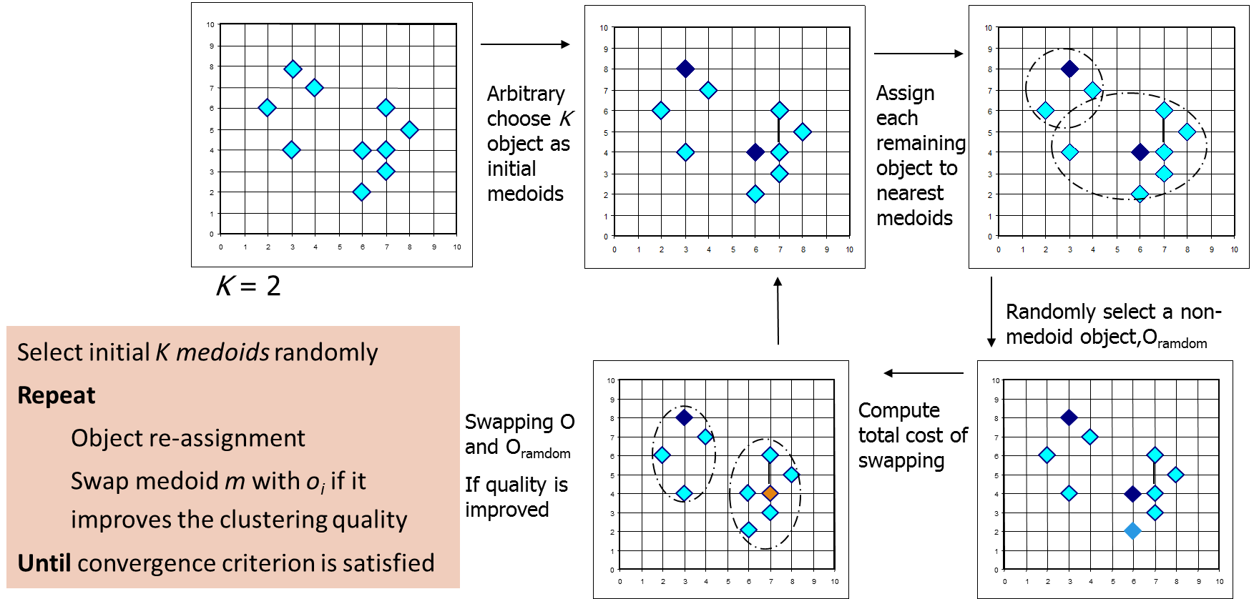

**Discussion on *K-Medoids* Clustering**

- K-Medoids Clustering: Find representative objects (medoids) in clusters - PAM (Partitioning Around Medoids: Kaufmann & Rousseeuw 1987) --- Starts from an initial set of medoids, and --- Iteratively replaces one of the medoids by one of the non-medoids if it improves the total sum of the squared errors (SSE) of the resulting clustering --- PAM works effectively for small data sets but does not scale well for large data sets (due to the computational complexity) --- Computational complexity: PAM: O(K(n − K)2) (quite expensive!) - Efficiency improvements on PAM --- CLARA (Kaufmann & Rousseeuw, 1990): ----- PAM on samples; O(Ks2 + K(n − K)), s is the sample size --- CLARANS (Ng & Han, 1994): Randomized re-sampling, ensuring efficiency + quality

***K-Medians*: Handling Outliers by Computing Medians**

- Medians are less sensitive to outliers than means --- Think of the median salary vs. mean salary of a large firm when adding a few top executives! - K-Medians: Instead of taking the mean value of the object in a cluster as a reference point, medians are used (L1-norm as the distance measure) - The criterion function for the K-Medians algorithm: $S=$ $\sum_{k=1}^{K}{\sum_{x_{i}∈k}{|x_{ij}-{med}_{kj}|}}$ The K-Medians clustering algorithm: --- Select K points as the initial representative objects (i.e., as initial K medians) --- Repeat ----- Assign every point to its nearest median ----- Re-compute the median using the median of each individual feature --- Until convergence criterion is satisfied

**K-Modes: Clustering Categorical Data**

- K-Means cannot handle non-numerical (categorical) data --- Mapping categorical value to 1/0 cannot generate quality clusters for high-dimensional data - K-Modes: An extension to K-Means by replacing means of clusters with modes - Dissimilarity measure between object X and the center of a cluster Z --- Φ(xj, zj) = 1 – njr/nl when xj = zj ; 1 when xj ǂ zj ----- where zj is the categorical value of attribute j in Zl, nl is the number of objects in cluster l, and njr is the number of objects whose attribute value is r - This dissimilarity measure (distance function) is frequency-based - Algorithm is still based on iterative object cluster assignment and centroid update - A fuzzy K-Modes method is proposed to calculate a fuzzy cluster membership value for each object to each cluster - A mixture of categorical and numerical data: Using a K-Prototype method

**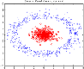*Kernel K-Means* Clustering**

- Kernel K-Means can be used to detect non-convex clusters --- K-Means can only detect clusters that are linearly separable - Idea: Project data onto the high-dimensional kernel space, and then perform K-Means clustering --- Map data points in the input space onto a high-dimensional feature space using the kernel function --- Perform K-Means on the mapped feature space - Computational complexity is higher than K-Means --- Need to compute and store n x n kernel matrix generated from the kernel function on the original data - The widely studied spectral clustering can be considered as a variant of Kernel K-Means clustering

**Kernel Functions and Kernel K-Means Clustering**

- Typical kernel functions: --- Polynomial kernel of degree h:  *K(Xi, Xj) = (Xi∙Xj + 1)h* --- Gaussian radial basis function (RBF) kernel*: K(Xi, Xj) = $e^{-{\left|\left|X_{i}-X_{j}\right|\right|}^{2}/2σ^2}$* --- Sigmoid kernel*: K(Xi, Xj) = tanh(κXi∙Xj −δ)* - The formula for kernel matrix K for any two points xi, xj є Ck is $K_{{x_{i}x}_{j}}= φ(x_{i})φ(x_{j})$- The SSE criterion of kernel K-means: $SSE\left(C\right)= \sum_{k=1}^{K}{\sum_{x_{i}∈k}{{\left|\left|φ(x_{i})-c_{k}\right|\right|}^{2}}}$--- The formula for the cluster centroid: $C_{k}= \sum_{x_{i}∈k}{φ(x_{i})/\left|C_{k}\right|}$- Clustering can be performed without the actual individual projections φ(xi) and φ(xj) for the data points xi, xj є Ck

**Example: Kernel Functions and Kernel K-Means Clustering**

*-* Gaussian radial basis function (RBF) kernel: K(Xi, Xj) = $e^{-{\left|\left|X_{i}-X_{j}\right|\right|}^{2}/2σ^2}$ *-* Suppose there are 5 original 2-dimensional points:

*---* x1(0, 0), x2(4, 4), x3(-4, 4), x4(-4, -4), x5(4, -4) *-* If we set 𝜎 to 4, we will have the following points in the kernel space *---* E.g., ||𝑥_1−𝑥_2 ||^2=(0−4)^2+(0−4)^2=32, therefore, 𝐾(𝑥_1,𝑥_2 )=𝑒^(−32/(2⋅4^2 ))=𝑒^(−1)

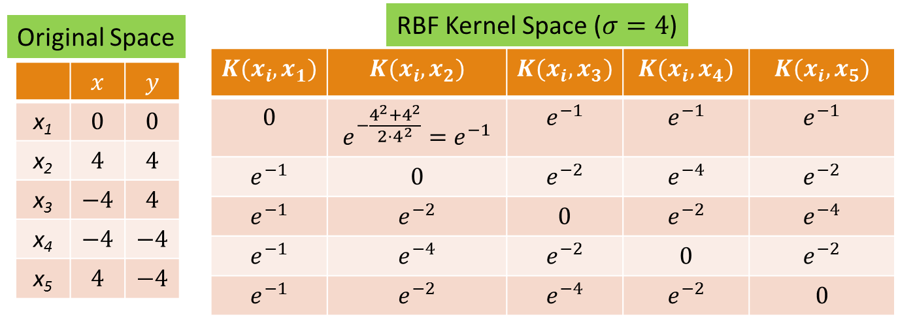

**Example: Kernel K-Means Clustering**

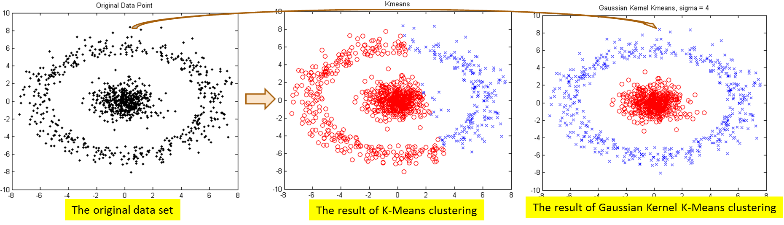

- The above data set cannot generate quality clusters by K-Means since it contains non-covex clusters - Gaussian RBF Kernel transformation maps data to a kernel matrix K for any two points xi, xj: and Gaussian kernel: *K*(***X****i*, ***Xj***) = - K-Means clustering is conducted on the mapped data, generating quality clusters

Hierarchical Clustering Methods

**Hierarchical Clustering: Basic Concepts**

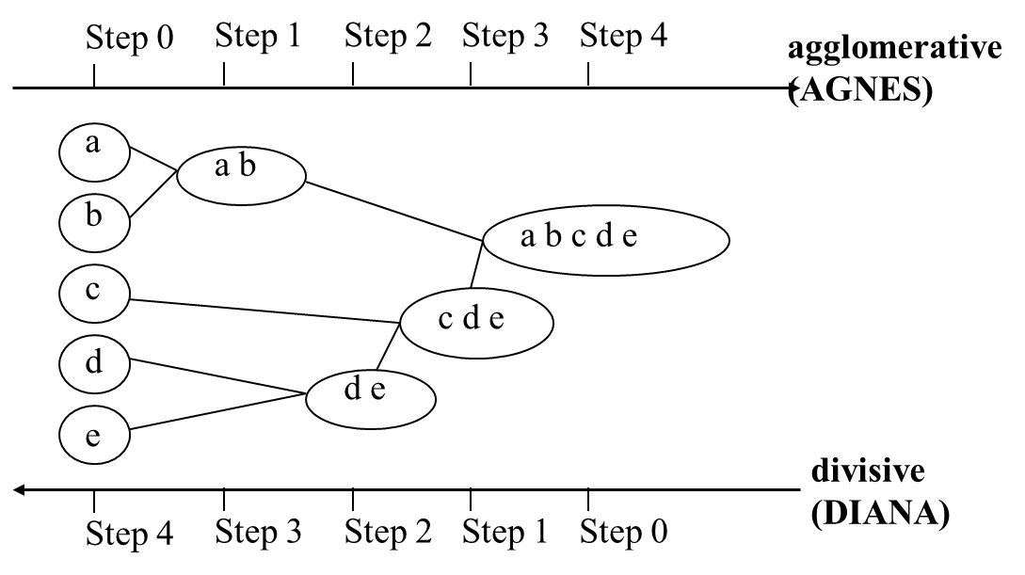- Hierarchical clustering

--- Generate a clustering hierarchy (drawn as a dendrogram) --- Not required to specify K, the number of clusters --- More deterministic --- No iterative refinement - Two categories of algorithms: --- Agglomerative: Start with singleton clusters, continuously merge two clusters at a time to build a **bottom-up** hierarchy of clusters --- Divisive**:** Start with a huge macro-cluster, split it continuously into two groups, generating a **top-down** hierarchy of clusters

**Dendrogram: Shows How Clusters are Merged**

- Dendrogram: Decompose a set of data objects into a tree of clusters by multi-level nested partitioning - A clustering of the data objects is obtained by cutting the dendrogram at the desired level, then each connected component forms a cluster

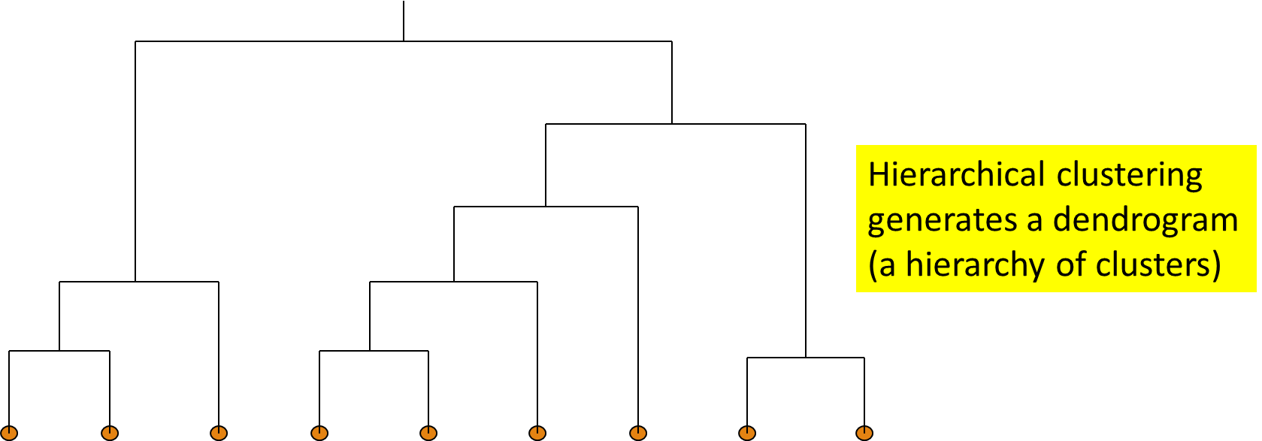

**Agglomerative Clustering Algorithm**

- AGNES (AGglomerative NESting) (Kaufmann and Rousseeuw, 1990) --- Use the single-link method and the dissimilarity matrix --- Continuously merge nodes that have the least dissimilarity --- Eventually all nodes belong to the same cluster

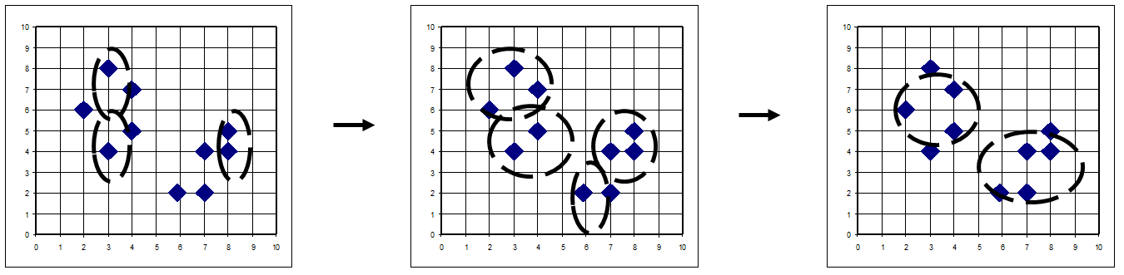

- Agglomerative clustering varies on different similarity measures among clusters --- Single link (nearest neighbor) --- Complete link (diameter) --- Average link (group average) --- Centroid link (centroid similarity)

**Single Link vs. Complete Link in Hierarchical Clustering**

- Single link (nearest neighbor) --- The similarity between two clusters is the similarity between their most similar (nearest neighbor) members --- Local similarity-based: Emphasizing more on close regions, ignoring the overall structure of the cluster --- Capable of clustering non-elliptical shaped group of objects --- Sensitive to noise and outliers - Complete link (diameter) --- The similarity between two clusters is the similarity between their most dissimilar members --- Merge two clusters to form one with the smallest diameter --- Nonlocal in behavior, obtaining compact shaped clusters --- Sensitive to outliers

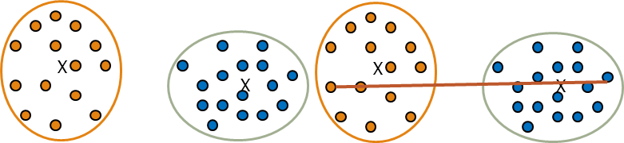

**Agglomerative Clustering: Average vs. Centroid Links**

- Agglomerative clustering with average link

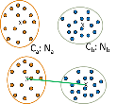--- Average link: The average distance between an element in one cluster and an element in the other (i.e., all pairs in two clusters) ----- Expensive to compute - Agglomerative clustering with centroid link

--- Centroid link: The distance between the centroids of two clusters - Group Averaged Agglomerative Clustering (GAAC) --- Let two clusters Ca and Cb be merged into CaUb. The new centroid is: $c_{a∪b}=\frac{N_{a}C_{a}+N_{b}C_{b}}{N_{a}+N_{b}}$

----- Na is the cardinality of cluster Ca, and ca is the centroid of Ca

--- The similarity measure for GAAC is the average of their distances

- Agglomerative clustering with Ward’s criterion --- Ward’s criterion: The increase in the value of the SSE criterion for the clustering obtained by merging them into Ca U Cb:

**Divisive Clustering**

- DIANA (Divisive Analysis) (Kaufmann and Rousseeuw,1990) --- Implemented in some statistical analysis packages, e.g., Splus - Inverse order of AGNES: Eventually each node forms a cluster on its own

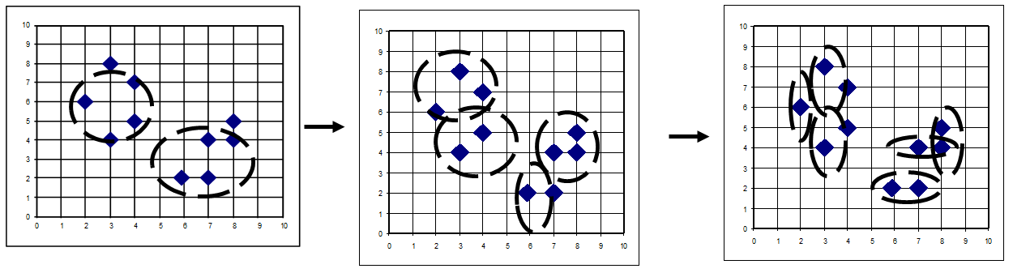

- Divisive clustering is a top-down approach --- The process starts at the root with all the points as one cluster --- It recursively splits the higher level clusters to build the dendrogram --- Can be considered as a global approach --- More efficient when compared with agglomerative clustering

**More on Algorithm Design for Divisive Clustering**

- Choosing which cluster to split --- Check the sums of squared errors of the clusters and choose the one with the largest value - Splitting criterion: Determining how to split --- One may use Ward’s criterion to chase for greater reduction in the difference in the SSE criterion as a result of a split --- For categorical data, Gini-index can be used

- Handling the noise --- Use a threshold to determine the termination criterion (do not generate clusters that are too small because they contain mainly noises)

**Extensions to Hierarchical Clustering**

- Major weaknesses of hierarchical clustering methods --- Can never undo what was done previously --- Do not scale well ----- Time complexity of at least O(n2), where n is the number of total objects

- Other hierarchical clustering algorithms --- BIRCH (1996): Use CF-tree and incrementally adjust the quality of sub-clusters --- CURE (1998): Represent a cluster using a set of well-scattered representative points --- CHAMELEON (1999): Use graph partitioning methods on the K-nearest neighbor graph of the data

**BIRCH (Balanced Iterative Reducing and Clustering Using Hierarchies)**

- A multiphase clustering algorithm (Zhang, Ramakrishnan & Livny, SIGMOD’96) - Incrementally construct a CF (Clustering Feature) tree, a hierarchical data structure for multiphase clustering --- Phase 1: Scan DB to build an initial in-memory CF tree (a multi-level compression of the data that tries to preserve the inherent clustering structure of the data) --- Phase 2: Use an arbitrary clustering algorithm to cluster the leaf nodes of the CF-tree - Key idea: Multi-level clustering --- Low-level micro-clustering: Reduce complexity and increase scalability --- High-level macro-clustering: Leave enough flexibility for high-level clustering - Scales linearly: Find a good clustering with a single scan and improve the quality with a few additional scans

**Clustering Feature Vector in BIRCH**

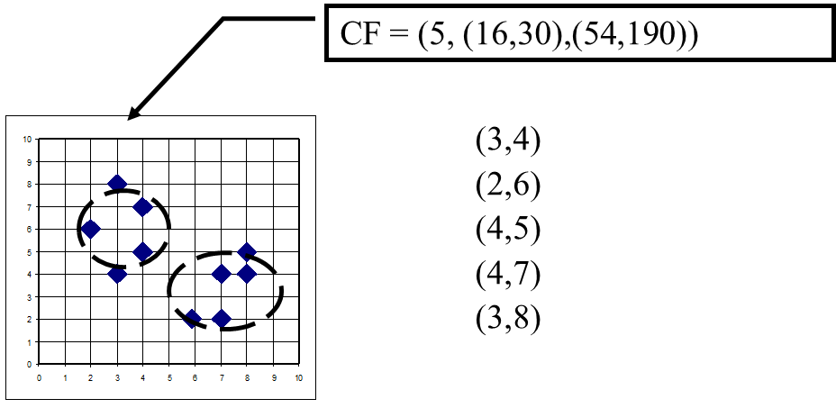- Clustering Feature (CF): CF = (N, LS, SS) --- N: Number of data points

--- LS: linear sum of N points: $\sum_{i=1}^{N}{X_{i}}$--- SS: square sum of N points:

- Clustering feature:

--- Summary of the statistics for a given sub-cluster: the 0-th, 1st, and 2nd moments of the sub-cluster from the statistical point of view

--- Registers crucial measurements for computing cluster and utilizes storage efficiently

**Measures of Cluster: Centroid, Radius and Diameter**

- Centroid: $\vec{x_{0}}= \frac{\sum_{i}^{n}{\vec{x_{i}}}}{n}$--- the “middle” of a cluster --- n: number of points in a cluster --- $\vec{x_{i}}$ is the i-th point in the cluster - Radius: R = $\sqrt{\frac{\sum_{i}^{n}{(\vec{x_{i}}- \vec{x_{0}})^2}}{n}}$--- Average distance from member objects to the centroid --- The square root of average distance from any point of the cluster to its centroid - Diameter: D = $\sqrt{\frac{\sum_{i}^{n}{\sum_{j}^{n}{(\vec{x_{i}}- \vec{x_{j}})^2}}}{n(n-1)}}$--- Average pairwise distance within a cluster --- The square root of average mean squared distance between all pairs of points in the cluster

**The CF Tree Structure in BIRCH**

- Incremental insertion of new points (similar to B+-tree) - For each point in the input -- Find closest leaf entry --- Add point to leaf entry and update CF --- If entry diameter > max_diameter ----- split leaf, and possibly parents - A CF tree has two parameters --- Branching factor: Maximum number of children --- Maximum diameter of sub-clusters stored at the leaf nodes - A CF tree: A height-balanced tree that stores the clustering features (CFs) - The non-leaf nodes store sums of the CFs of their children

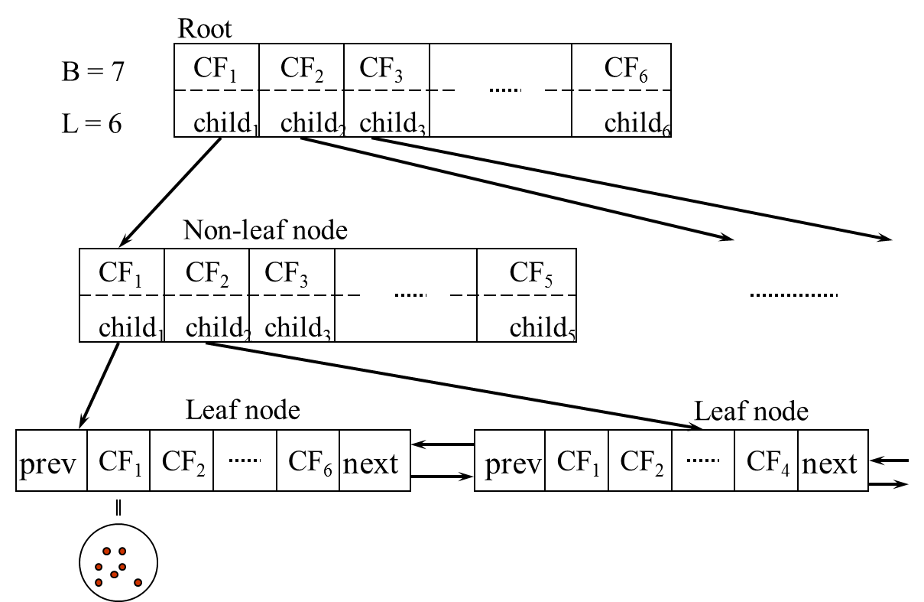

**BIRCH: A Scalable and Flexible Clustering Method**

- An integration of agglomerative clustering with other (flexible) clustering methods --- Low-level micro-clustering ----- Exploring CP-feature and BIRCH tree structure ----- Preserving the inherent clustering structure of the data --- Higher-level macro-clustering ----- Provide sufficient flexibility for integration with other clustering methods - Impact to many other clustering methods and applications

- Concerns --- Sensitive to insertion order of data points --- Due to the fixed size of leaf nodes, clusters may not be so natural --- Clusters tend to be spherical given the radius and diameter measures

**CURE: Clustering Using Representatives**

- CURE (Clustering Using REpresentatives) (S. Guha, R. Rastogi, and K. Shim, 1998) --- Represent a cluster using a set of well-scattered representative points - Cluster distance: Minimum distance between the representative points chosen --- This incorporates features of both single link and average link - Shrinking factor α: The points are shrunk towards the centroid by a factor α --- Far away points are shrunk more towards the center: More robust to outliers - Choosing scattered points helps CURE capture clusters of arbitrary shapes

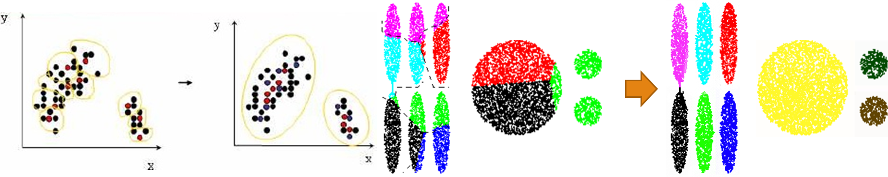

**CHAMELEON: Hierarchical Clustering Using Dynamic Modeling**

- CHAMELEON: A graph partitioning approach (G. Karypis, E. H. Han, and V. Kumar, 1999) - Measures the similarity based on a dynamic model --- Two clusters are merged only if the interconnectivity and closeness (proximity) between two clusters are high relative to the internal interconnectivity of the clusters and closeness of items within the clusters - A graph-based, two-phase algorithm --- Use a graph-partitioning algorithm: Cluster objects into a large number of relatively small sub-clusters --- Use an agglomerative hierarchical clustering algorithm: Find the genuine clusters by repeatedly combining these sub-clusters

**Overall Framework of CHAMELEON**

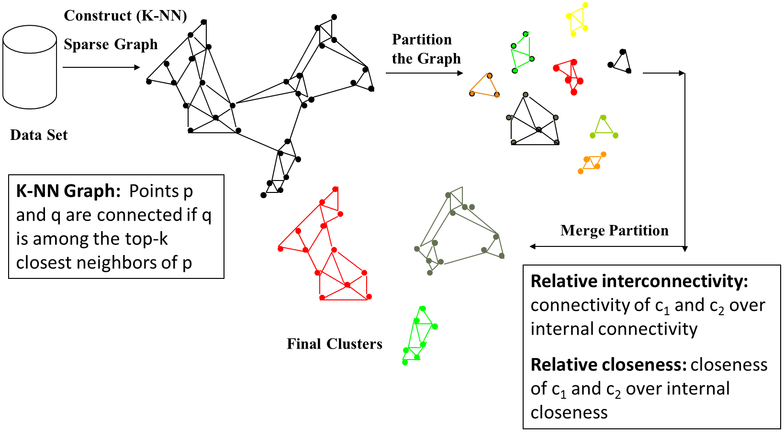

**KNN Graphs and Interconnectivity**

- K-nearest neighbor (KNN) graphs from an original data in 2D:

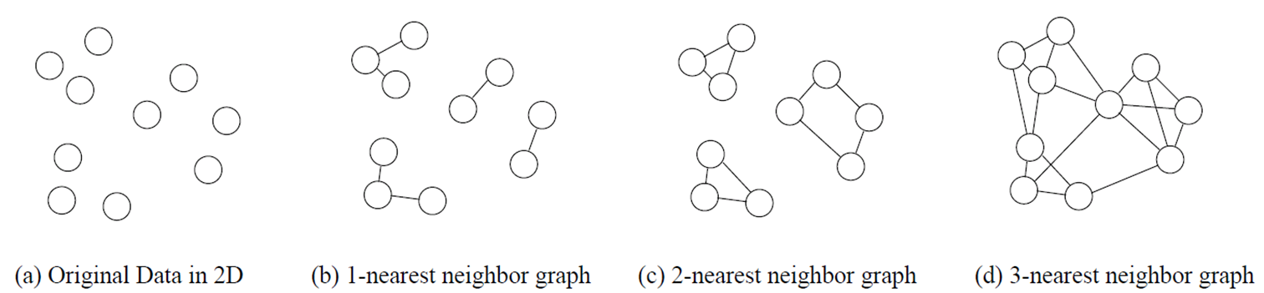

- EC{Ci ,Cj } :The absolute interconnectivity between Ci and Cj:

--- The sum of the weight of the edges that connect vertices in Ci to vertices in Cj - Internal interconnectivity of a cluster Ci : The size of its min-cut bisector ECCi (i.e., the weighted sum of edges that partition the graph into two roughly equal parts)

- Relative Interconnectivity (RI):

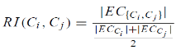

**Relative Closeness & Merge of Sub-Clusters**

- Relative closeness between a pair of clusters Ci and Cj : The absolute closeness between Ci and Cj normalized w.r.t. the internal closeness of the two clusters Ci and Cj

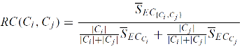

--- where 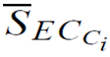 and 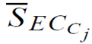 are the average weights of the edges that belong to the min-cut bisector of clusters Ci and Cj , respectively, and  is the average weight of the edges that connect vertices in Ci to vertices in Cj

- Merge Sub-Clusters:

--- Merges only those pairs of clusters whose RI and RC are both above some user-specified thresholds

--- Merge those maximizing the function that combines RI and RC

**CHAMELEON: Clustering Complex Objects**

- CHAMELEON is capable to generate quality clusters at clustering complex objects

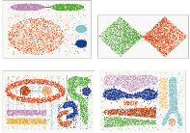

**Probabilistic Hierarchical Clustering**

- Algorithmic hierarchical clustering --- Nontrivial to choose a good distance measure --- Hard to handle missing attribute values --- Optimization goal not clear: heuristic, local search - Probabilistic hierarchical clustering --- Use probabilistic models to measure distances between clusters --- Generative model: Regard the set of data objects to be clustered as a sample of the underlying data generation mechanism to be analyzed --- Easy to understand, same efficiency as algorithmic agglomerative clustering method, can handle partially observed data - In practice, assume the generative models adopt common distribution functions, e.g., Gaussian distribution or Bernoulli distribution, governed by parameters

**Generative Model**

- Given a set of 1-D points X = {x1, …, xn} for clustering analysis & assuming they are generated by a Gaussian distribution:



- The probability that a point xi ∈ X is generated by the model:

- The likelihood that X is generated by the model:

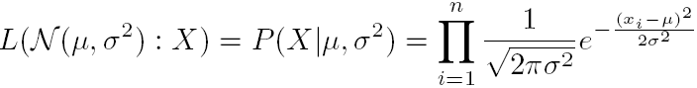

-The task of learning the generative model: find the parameters μ and σ2 such that

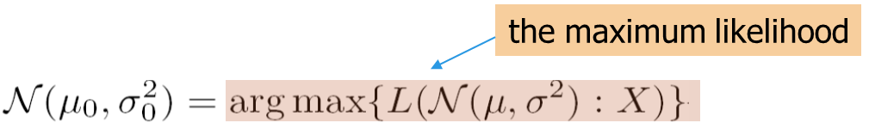

**Gaussian Distribution**

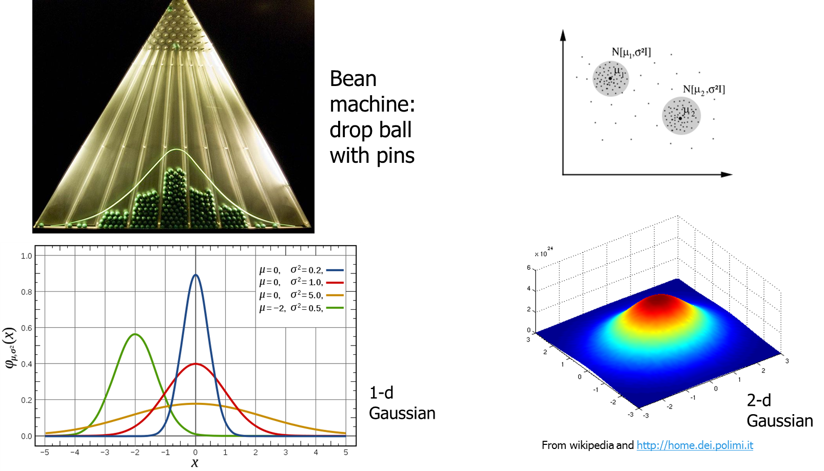

**A Probabilistic Hierarchical Clustering Algorithm**

- For a set of objects partitioned into m clusters C1, . . . ,Cm, the quality can be measured by,

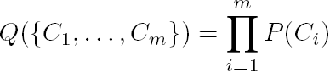

where P() is the maximum likelihood

- If we merge two clusters Cj1 and Cj2 into a cluster Cj1∪Cj2, the change in quality of the overall clustering is

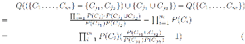

- Distance between clusters C1 and C2:

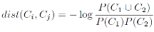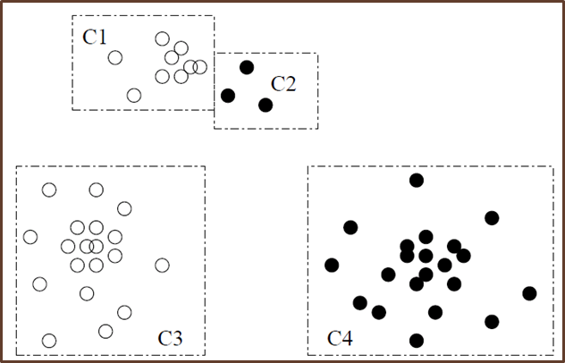

- If dist(Ci, Cj) < 0, merge Ci and Cj

Density-Based and Grid-Based Clustering Methods

**Density-Based Clustering Methods**

- Clustering based on density (a local cluster criterion), such as density-connected points - Major features: --- Discover clusters of arbitrary shape --- Handle noise --- One scan (only examine the local region to justify density) --- Need density parameters as termination condition - Several interesting studies: --- DBSCAN: Ester, et al. (KDD’96) --- OPTICS: Ankerst, et al (SIGMOD’99) --- DENCLUE: Hinneburg & D. Keim (KDD’98) --- CLIQUE: Agrawal, et al. (SIGMOD’98) (also, grid-based)

**DBSCAN: A Density-Based Spatial Clustering Algorithm**

- DBSCAN (M. Ester, H.-P. Kriegel, J. Sander, and X. Xu, KDD’96) --- Discovers clusters of arbitrary shape: Density-Based Spatial Clustering of Applications with Noise - A density-based notion of cluster --- A cluster is defined as a maximal set of density-connected points - Two parameters: --- Eps (ε): Maximum radius of the neighborhood --- MinPts: Minimum number of points in the

Eps-neighborhood of a point - The Eps(ε)-neighborhood of a point q:

--- NEps(q): {p belongs to D | dist(p, q) ≤ Eps}

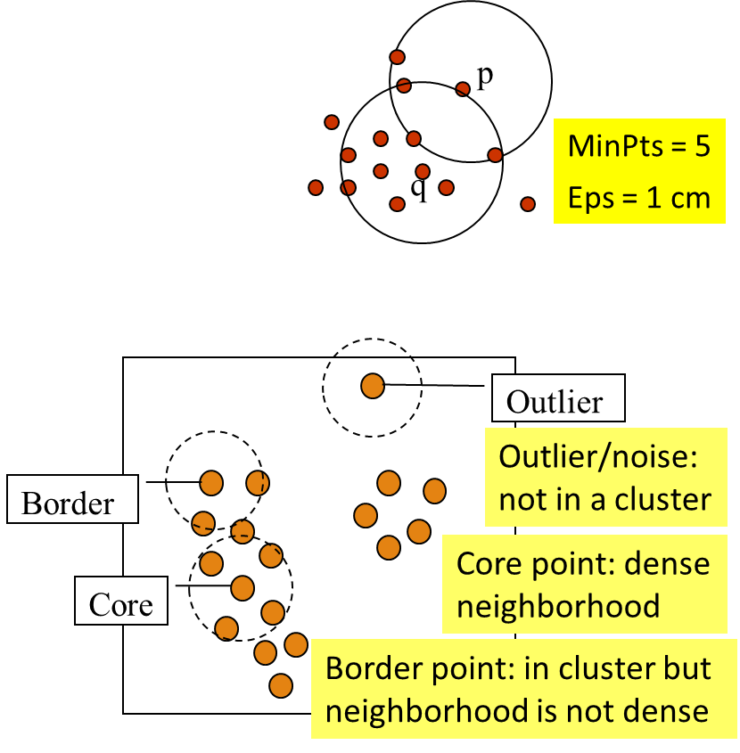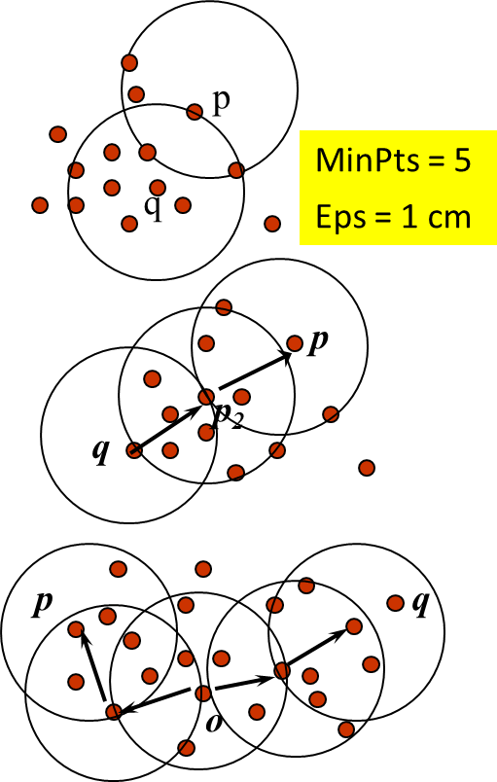

**DBSCAN: Density-Reachable and Density-Connected**

- Directly density-reachable: --- A point p is directly density-reachable from a point q w.r.t. Eps (ε), MinPts if ----- p belongs to NEps(q) ----- core point condition: |NEps (q)| ≥ MinPts - Density-reachable: --- A point p is density-reachable from a point q w.r.t. Eps, MinPts if there is a chain of points p1, …, pn, p1 = q, pn = p such that pi+1 is directly density-reachable from pi - Density-connected: --- A point p is density-connected to a point q w.r.t. Eps, MinPts if there is a point o such that both p and q are density-reachable from o w.r.t. Eps and MinPts

**DBSCAN: The Algorithm**

- Algorithm --- Arbitrarily select a point p --- Retrieve all points density-reachable from p w.r.t. Eps and MinPts ----- If p is a core point, a cluster is formed ----- If p is a border point, no points are density-reachable from p, and DBSCAN visits the next point of the database --- Continue the process until all of the points have been processed - Computational complexity --- If a spatial index is used, the computational complexity of DBSCAN is O(nlogn), where n is the number of database objects --- Otherwise, the complexity is O(n2)

**DBSCAN Is Sensitive to the Setting of Parameters**

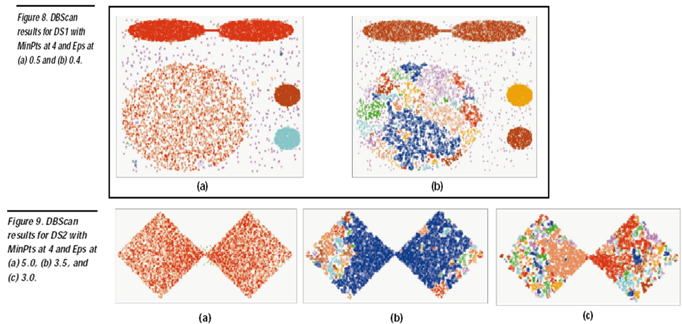

**OPTICS: Ordering Points To Identify Clustering Structure**

- OPTICS (Ankerst, Breunig, Kriegel, and Sander, SIGMOD’99) --- DBSCAN is sensitive to parameter setting --- An extension: finding clustering structure - Observation: Given a MinPts, density-based clusters w.r.t. a higher density are completely contained in clusters w.r.t. to a lower density - Idea: Higher density points should be processed first—find high-density clusters first - OPTICS stores such a clustering order using two pieces of information: --- Core distance and reachability distance

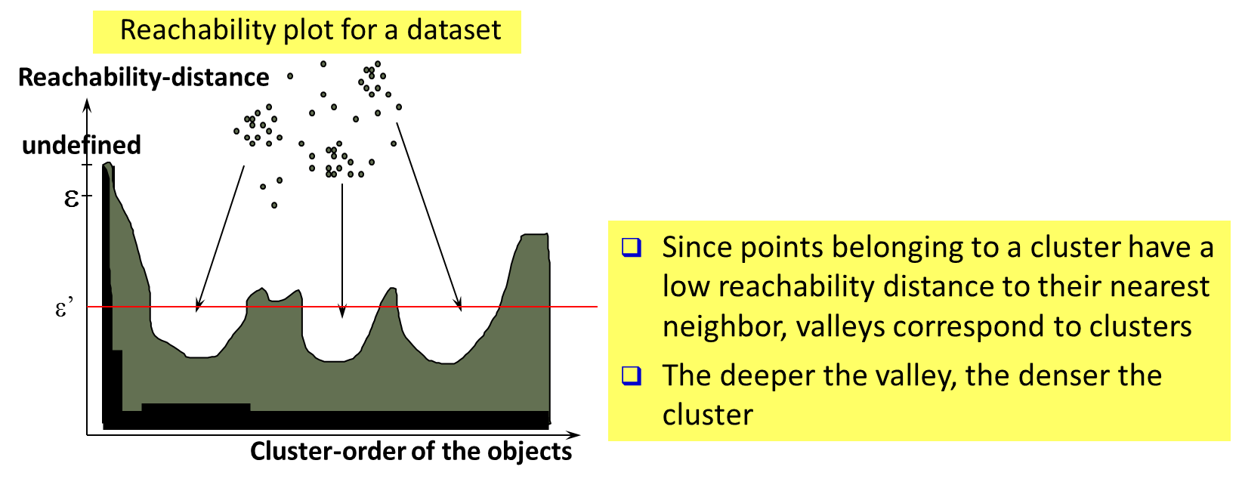

**OPTICS: An Extension from DBSCAN**

- Core distance of an object p: The smallest value ε such

that the ε-neighborhood of p has at least MinPts objects

Let Nε(p): ε-neighborhood of p

ε is a distance value

Core-distanceε, MinPts(p) = Undefined if card(Nε(p)) < MinPts

Or MinPts-distance(p), otherwise

- Reachability distance of object *p* from core object *q* is the min. radius value that makes *p* density-reachable from *q*

Reachability-distance*ε*, *MinPts*(*p*, *q*) =

Undefined, *if q is not a core object*

max(core-distance(*q*), distance (*q*, *p*)), *otherwise*

- Complexity: O(*N* log*N*) (if index-based) --- where *N*: # of points

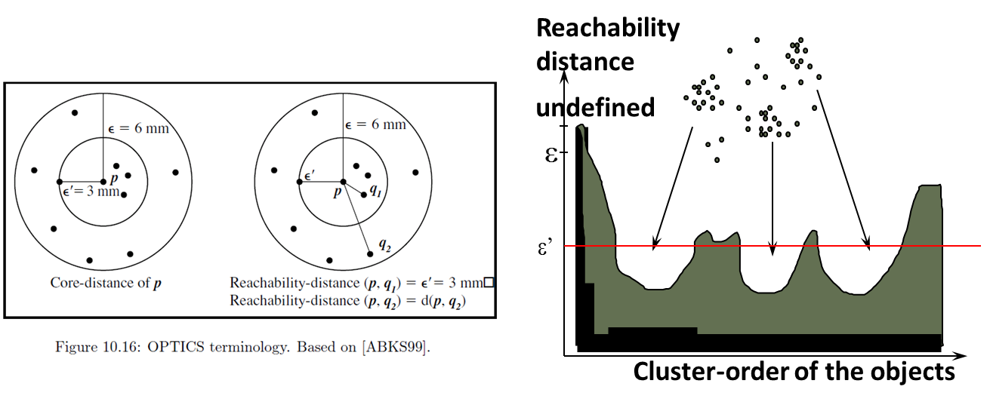

**OPTICS: Finding Hierarchically Nested Clustering Structures**

- OPTICS produces a special cluster-ordering of the data points with respect to its density-based clustering structure --- The cluster-ordering contains information equivalent to the density-based clusterings corresponding to a broad range of parameter settings --- Good for both automatic and interactive cluster analysis—finding intrinsic, even hierarchically nested clustering structures

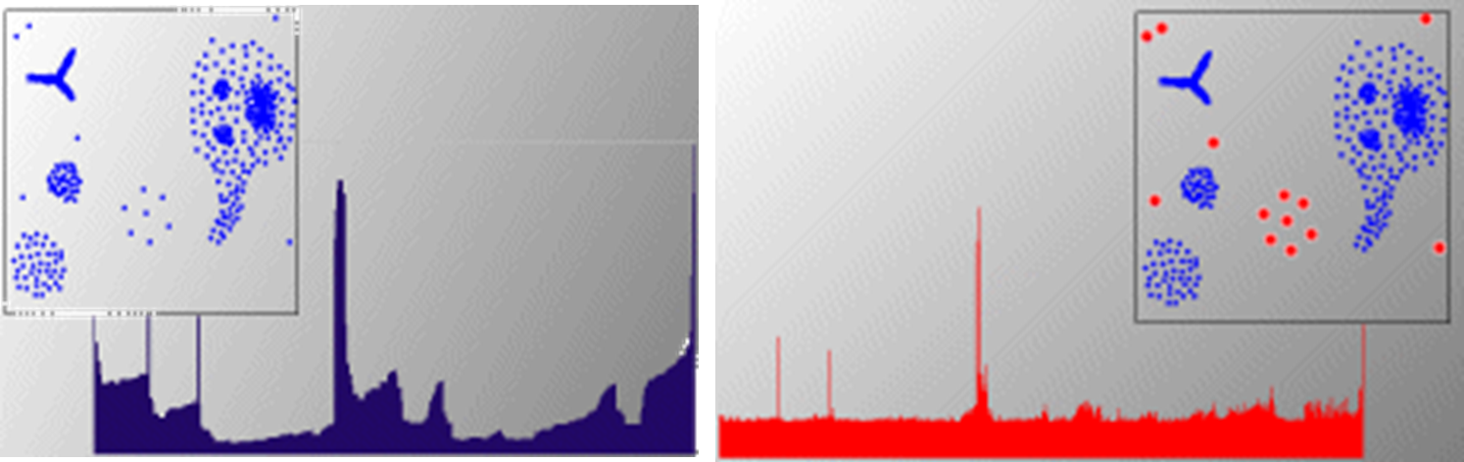

**Grid-Based Clustering Methods**

- Grid-Based Clustering: Explore multi-resolution grid data structure in clustering --- Partition the data space into a finite number of cells to form a grid structure --- Find clusters (dense regions) from the cells in the grid structure - Features and challenges of a typical grid-based algorithm --- Efficiency and scalability: # of cells << # of data points

--- Uniformity: Uniform, hard to handle highly irregular data distributions --- Locality: Limited by predefined cell sizes, borders, and the density threshold --- Curse of dimensionality: Hard to cluster high-dimensional data - Methods to be introduced --- STING (a STatistical INformation Grid approach) (Wang, Yang and Muntz, VLDB’97) --- CLIQUE (Agrawal, Gehrke, Gunopulos, and Raghavan, SIGMOD’98) ----- Both grid-based and subspace clustering

**STING: A Statistical Information Grid Approach**

- STING (Statistical Information Grid) (Wang, Yang and Muntz, VLDB’97) - The spatial area is divided into rectangular cells at different levels of resolution, and these cells form a tree structure - A cell at a high level contains a number of smaller cells of the next lower level - Statistical information of each cell is calculated and stored beforehand and is used to answer queries - Parameters of higher level cells can be easily calculated from that of lower level cell, including --- count, mean, s(standard deviation), min, max --- type of distribution—normal, uniform, etc.



**Query Processing in STING and Its Analysis**

- To process a region query --- Start at the root and proceed to the next lower level, using the STING index --- Calculate the likelihood that a cell is relevant to the query at some confidence level using the statistical information of the cell --- Only children of likely relevant cells are recursively explored --- Repeat this process until the bottom layer is reached – Advantages --- Query-independent, easy to parallelize, incremental update --- Efficiency: Complexity is O(K)

----- K: # of grid cells at the lowest level, and K << N (i.e., # of data points) – Disadvantages --- Its probabilistic nature may imply a loss of accuracy in query processing

**CLIQUE: Grid-Based Subspace Clustering**

- CLIQUE (Clustering In QUEst) (Agrawal, Gehrke, Gunopulos, Raghavan: SIGMOD’98) - CLIQUE is a **density-based** and **grid-based subspace** clustering algorithm --- Grid-based: It discretizes the data space through a grid and estimates the density by counting the number of points in a grid cell --- Density-based: A cluster is a maximal set of connected dense units in a subspace ----- A unit is dense if the fraction of total data points contained in the unit exceeds the input model parameter --- Subspace clustering: A subspace cluster is a set of neighboring dense cells in an arbitrary subspace. It also discovers some minimal descriptions of the clusters - It automatically identifies subspaces of a high dimensional data space that allow better clustering than original space using the Apriori principle

**CLIQUE: SubSpace Clustering with Aprori Pruning**

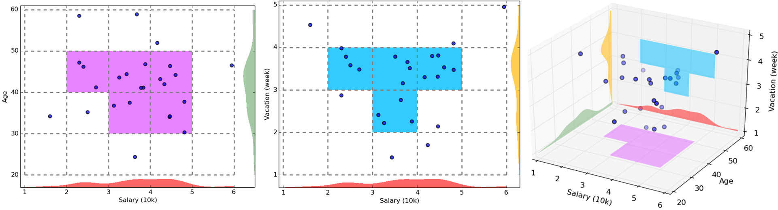

- Start at 1-D space and discretize numerical intervals in each axis into grid - Find dense regions (clusters) in each subspace and generate their minimal descriptions - Use the dense regions to find promising candidates in 2-D space based on the Apriori principle - Repeat the above in level-wise manner in higher dimensional subspaces

**Major Steps of the CLIQUE Algorithm**

- Identify subspaces that contain clusters --- Partition the data space and find the number of points that lie inside each cell of the partition --- Identify the subspaces that contain clusters using the Apriori rinciple - Identify clusters --- Determine dense units in all subspaces of interests --- Determine connected dense units in all subspaces of interests - Generate minimal descriptions for the clusters --- Determine maximal regions that cover a cluster of connected dense units for each cluster --- Determine minimal cover for each cluster

**Additional Comments on *CLIQUE***

- Strengths --- Automatically finds subspaces of the highest dimensionality as long as high density clusters exist in those subspaces --- Insensitive to the order of records in input and does not presume some canonical data distribution --- Scales linearly with the size of input and has good scalability as the number of dimensions in the data increases – Weaknesses --- As in all grid-based clustering approaches, the quality of the results crucially depends on the appropriate choice of the number and width of the partitions and grid cells